


Exor Corporation Limited
The Global Leader in
Infrastructure Asset Management
Maintenance Manager V 4.0
System Administration Guide

This page intentionally blank

Quality Assurance Statement

Document Details
File:  Maintenance Manager v4 System Admin Guide.doc | Prepared by:  Ian Skinner
Manual Name:  Maintenance Manager System Administration | Reviewed by:
Version:  2 | Approved for issue by:  C. Stewart
Date of Issue: | Product Manager:  Ian Skinner
File Name:
\\Documentation\nm3_official\released with 4.0\ maintenance manager v4 sys admin.doc

Document Version Control
Revision | Date | By | Chapter / Page | Description
4.0.2.0 | 25 October 2007 | IES |  | General revisions for release 4.0.2.0

CONTENTS

Introduction 1
Configuring Core Modules 4
Product Options – HIG9130 5
Interval Codes - HIG1220 22
Defect Status Codes - HIG9110 24
Financial Reference Data 26
Job Size Codes - MAI3666 28
Item Code Breakdowns - MAI1940 29
Cost Centre Codes - MAI3844 32
VAT Rates - MAI3846 33
Budget Maintenance 34
Budgets - MAI3660 35
Generate Budgets for Next Year - MAI3662 38
Maintenance Reference Data 39
Activities - MAI1200 40
Activity Groups - MAI1205 44
Local Activity Frequencies - MAI1210 45
Default Section Intervals Calculation - MAI1230 47
Default Section Intervals - Override - MAI1240 49
Valid for Maintenance Rules - MAI3440 51
Related Maintenance Activities - MAI3628 52
Cyclic Maintenance Inventory Rules - MAI3626 53
Works Order Auditing Maintenance - MAI3803 55
Asset Activities – MAI3632 56
Budget Allocations – MAI3630 57
Work Order priorities – MAI0132 59
Inspection Reference Data 60
Organisations - MAI1870 61
People - MAI1830 62
Defect Control Data - MAI1300 63
Defect Priorities - MAI3812 65
Maintain Automatic Defect Prioritisation – MAI3813 67
Treatment Data - MAI1315 69
Treatment Models - MAI3814 71
Default Treatments - MAI3150 73
Enquiry/Treatment Types – MAI1320 75
Enquiry/Treatment Priorities – MAI1325 77
Contracts and Contractors 78
Standard Items - MAI3888 80
Standard Item Sections and Sub-Sections - MAI3886 84
Contractors - MAI3881 86
Contracts - MAI3880 88
Copy a Contract - MAI3882 93
Bulk Update of Contract Items - MAI3884 94
Discount Groups - MAI3624 96

CHAPTER
1
Introduction
maintenance manager by exor is an application module that is used in conjunction with network manager by exor to manage the maintenance functions for a transportation network and its associated attributes.
maintenance manager provides complete control over the management and operation of routine, cyclic and structural maintenance and allows the user to maintain financial control of maintenance contracts and budgets. It aids in the implementation of policy standards and provides facilities for monitoring performance against these standards. This ensures effective work management. In addition, maintenance manager allows for the implementation of inspection regimes and so provides a legal framework for defending liability claims.
Tools are available within maintenance manager to record and manage, in a user-defined manner, information concerning:

      - inspections; planned, reactive, ad-hoc and quality. Planning of surveys, performance reporting, and integration with mobile Data Collection Devices (DCD) are key features.
      - defects; with definable priority codes and status and an inventory change indicator Full on-line reporting allows managers to readily assess maintenance needs.
      - treatments; treatment models translate defect treatments into sets of pre-defined Bill Of Quantity (BOQ) items that allow engineers to easily translate defects into work packages.
      - contracts; holding estimates, actuals and retentions for any pre-defined work type. Managers can therefore have direct access to up-to-date budget positions at any time.
      - works orders; defect, cyclic and scheme works orders. Automatic costing for multiple contracts and multiple budget codes, allowing for variations and interim payments. Work can be grouped based on location, pricing, budget code, defect priority and BOQ item. Using these tools engineers can benefit by comparing scenarios to plan cost-effective and timely work solutions.
      - resources; such as contractors, schedule of rates, and budgets. Budgets may be set for any area, financial period or type of work and can be continually monitored and trends examined. They may be integrated with Corporate Financial Systems or linked to standard office tools such as desktop spreadsheets for budget profiling. In addition the on-line assessment of contractor and labour availability is a clear benefit. maintenance manager also interfaces into contractor-based systems which manage the labour, plant and materials primitives that make up the higher level BOQ.
maintenance manager includes a wide range of standard reports that enable performance to be monitored against predetermined standards. These measures include how quickly defects of given priorities are repaired and can be used to monitor inspectors, contracts and budgets.
maintenance manager by exor is supplied with a standard set of activities, interval codes, defects and treatments, these can be modified and added to to suit your own operational requirements if required using the modules contained within this chapter.
This System Administration Manual is one of four manuals that are provided with each copy of Maintenance Manager by Exor (MM). Those manuals are:
  - Installation Manual: Describes how to install MM on different computing environments;
  - Administration Manual: Describes how to configure MM metadata and initially populate MM tables to conform to an organization’s business processes;
  - User Manual: Describes how to use MM on a daily basis to manage the preventative, recurring and ad hoc maintenance and repair activity: and
  - Loader Manual: Describes how to download and upload information between MM and other applications or Data Collection Devices (lap tops, pen based, PDAs, etc.)
This System Administration Manual is intended for those who will administer the maintenance program and initially define, set-up, configure and maintain the metadata used by MM for the users. Depending on the needs and complexity of the organization, defining the metadata, configuring this software and loading initial data into the system tables can be quite detailed or relatively simple and the processes described herein could take months or days.
Configuring Maintenance Manager Metadata
Before MM can be used to perform inspections, identify work requirements, manage contractors, create work orders, apply standard treatments, track financial and budget information and produce essential reports, it must first be configured to model each unique organization. This configuration provides essential, relatively stable (changes rarely) information to support Maintenance Manager functions. Examples would be work calendar, budget categories, standard treatments, fiscal years, available contractors, and so forth.
The information that describes the type of data required for a particular organization is called metadata, because it contains information about the data. MM can be provided with standard metadata, can be configured to precisely match your exact business process, or can contain both standard metadata and configured metadata. Furthermore, the metadata within MM can be changed whenever a change in the business process requires different types of data. These changes are data stamped and will not cause the loss of critical historical information.
The configuration process generally requires a thorough analysis of how an organization performs its maintenance functions and in some cases presents an opportunity to review those practices to determine if they are the most effect way to do business. The most successful organizations appoint a Implementation Manager and Exor Systems Administrator to manage the set up process and then maintain essential system data throughout the life of the application. While the System Administrator should have some knowledge of Oracle software, it is more important that this individual has a comprehensive understanding of the maintenance function within the organization. In addition, successful organizations generally create an implementation team consisting of not only maintenance managers but also Information Systems, financial and procurement personnel, to provide information and assistance to the Systems Administrator during the initial, one time software configuration phase.
Initial Population of Maintenance Manager Tables
Once the metadata is configured, certain basic information must be entered into the Maintenance Manager tables to give the software meaning. This is true for any software program that must be customized. For example, a software package to manage contacts would be worthless unless the user entered the name, address, phone, email and other information about each of their contacts.
This manual identifies how to populate the Maintenance Manager tables with the minimum amount of information needed to make MM a meaningful tool for maintenance management. Just as in the case with software to manage contacts, as used in the example, this data is not expected to maintain static, although it will change less often than data entered by the daily user. This data is addressed in this manual, and not the Users’ Manual because most organizations will normally limit the entry of financial and procedural data to the System Administrator and other key individuals.
CHAPTER
2
Configuring Core Modules
Before the Maintenance Manager modules can be configured and populated, Product Options, Network Information, and Inventory (Assets) must be configured in the Core Network Manager Module. Unlimited access to these modules should be limited to the System Administrator. Maintenance Manager users should have limited read only access to the Network and Assets and no access to Product Options.
The easiest way to access the core modules from Maintenance Manager is by using “Fastpath”, which is located under the “File” menu and appears as follows:
Figure 1
Fastpath
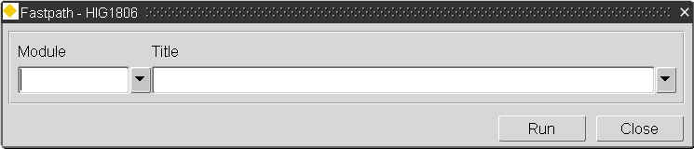

Product Options – HIG9130
Figure 2
Product Options
Menu Option
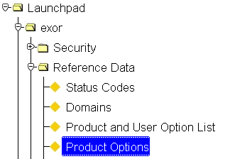

Figure 3
Product Options

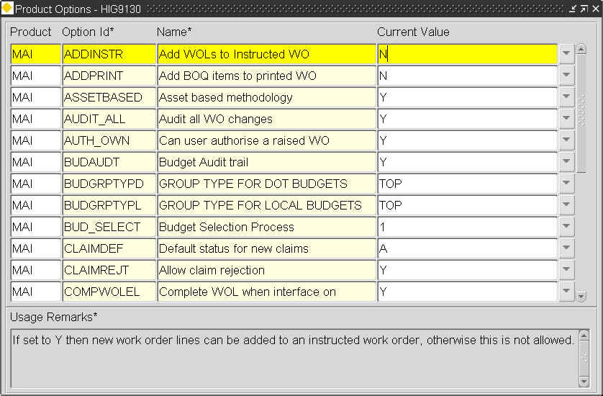

The following Product Options - HIG9130 will also need checking to ensure the system is configured to match the organization’s business process requirements. Product options are usually set up and maintained by the system administrator.

ADDINSTR
Add Work Order Lines to an instructed works order
Enter “Y” or “N”
If a value of “Y” is entered new work order lines can be added to an instructed works order, otherwise this is not allowed.
ADDPRINT
Add BOQ items to a printed works order.
Enter “Y” or “N”
If a value of “Y” is entered a user can add BOQ items to a Works Order Line after the Works Order has been printed.

ASSETBASED
Asset Based Methodology.
Enter “Y” or “N”
If a value of “Y” is entered the system will be set up for Asset-based working allowing users to log defects directly against an asset when using Inspections – MAI3808.
AUDIT_ALL
Audit all works order changes.
Enter “Y” or “N”
This option is used to restrict the size of the audit log trail.
If a value of “Y” is entered every change a user makes to a work order will be audited regardless of the number of times the record is saved. This auditing will only work on those auditable items that have been previously selected in Works Order Auditing – MAI3803.
If a value of “N” is entered intermediate user changes will not be logged.
In this case the audit log will show the beginning and end values for a session but no other changes.

The works order audit trail can be viewed by selecting the expand button when in the first window of the works ordering module.

AUTH_OWN
Can user authorise a raised WO.
Enter “Y” or “N”
If a value of “Y” is entered it is possible for a user who raised a works order to authorise (instruct) the works order.
If a value of “N” is entered another user will have to authorise the raised WO.

The minimum and maximum values a user is allowed to raise and authorize when using works ordering is defined in Users - HIG1832.

BUDAUDT
Budget audit trail.
This product option is an administration facility to be used by exor staff only for diagnostic purposes then switched off immediately after use.
Enter “Y” or “N”
If a value of “Y” is entered the system will write a full audit trail of selected fields to the temporary table BUDGET_AUDIT_TRAIL.
If a value of “N” is entered the auditing will be switched off.
BUDGRPTYPD and BUDGRPTYPL
Budget group type for DoT roads and Local roads, respectively.

Enter a valid Road Group Type. These group types will have been previously set up using Group Types - NM0004.
It defines how budgets are maintained for trunk and local roads.
In Budgets - MAI3660 you may only create trunk road budgets against groups of this type.
In Print Budget Exceptions (MAI3690) you may only select groups of this type for trunk road report parameters.
English trunk road authorities must always use RP (for Road Parts).
This option must not be amended on a live system.
BUD_SELECT
Budget selection process.
This option defines the number of stages involved in selecting a budget for a work order line.
Enter “1” or “2”
If a value of “1” is entered the system will invoke a single stage process for selecting both the work category and budget details in one list as shown below:
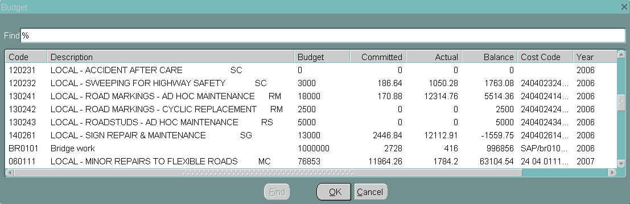

If a value of “2” is entered the system will invoke a two stage process first allowing the user to select the work category:
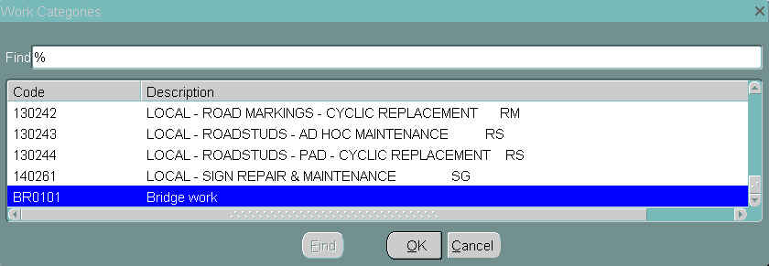

Followed by the budget and budget group selection:
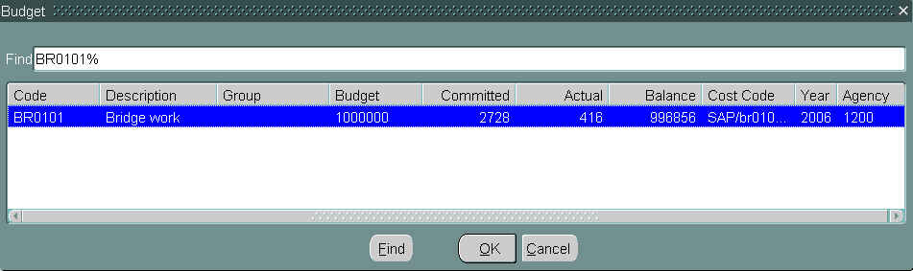

Sites with large amounts of data should use the 2 stage selection process. This value can be modified at any time.

CLAIMDEF
Used when setting up the Contractor Interface Modile - CIM
Default status for new claims when an interface file is processed.
Default new claim records to this status (currently A - Approved or H - Held)
This is the default status for a works order line when processed in the payment run module.
CLAIMREJT
Determines whether or not users can reject claims in the claim verification form
Enter “Y” or “N”.
COMPWOLEL
This option is dependant on the setting of the electronic orders flag for a contractor.
Enter “Y” or “N”.
If the option is set to N and the contractor uses electronic orders then the user will not be able to update the order line status from Instructed to Completed.
CONINTRM
Allow Interim at Valuation.
Enter “Y” or “N”.
If this option is set to Y then a user can set the WOL status to INTERIM from VALUATION.
CPAFORMAT
Format of Works Order Number.
Enter “0” or “1”
Set to 0 to show standard format, 1 to show Causeway format.
CPAINTERIM
CPA Interims.
Enter “0” or “1”
Set to 1 to allow Causeway to process interim payments.
CSVSEPVAL
CSV File Separator.
This character is used by the data loaders as the separator between fields.
CUM_PERC
Computation of Percentage item.
Enter “NORMAL” or “CULMATIVE” any other value will be ignored.
This determines the computation method for a percentage item.
When set to NORMAL a percentage item will display the percentage of the standard item.
A setting of CUMULATIVE will result in the percentage item being the sum of the percentage of the standard item and other percentage items related to the standard item.
CYCGRPTYPD & CYCGRPTYPL
This must contain a list of valid Road Group Types, in the format: LINK,RP,ROUT.
It defines how cyclic maintenance schedules are maintained for both local and trunk roads.
In Maintain Schedules (MAI3860) you may only create schedules against groups of these types.
This option may be amended on a live system, however you should immediately update the road group on current schedules, for consistency.
DEFAUTOPRI
Defect Automatic Priority.
Enter “A” or “B” or leave blank (NULL)
This option applies automatic defect prioritisation when a defect is entered during an inspection based on the rules established in the Maintain Automatic Defect Priority form MAI3818
When the value is set to ‘A’, the Inspections form MAI3808 form will behave slightly differently.
If set to ‘A’, Defect Priority is no longer required (manually imput by user). You can tab around it without entering. The field is NOT enabled.
Once you have entered a Defect Code, the rules table the Maintain Automatic Defect Priority form MAI3818 is checked and the lowest priority for the particular Activity Code, Defect Code and Road Attribute combination. The user will NOT be able to over-type this value once committed. If no Priority is found, then an error will be returned.
If set to ‘B’, then MAI3808 will allow you to manually overtype the value of Priority derived from rules table.
If Product option is set to NULL, MAI3808 will behave as normal.
If inspections are entered via the loaders, a value of ‘A’ will overwrite the entered priorities with the auto priorities, so the inspector can put in a dummy value or leave the priority blank in the field.
This is also a user option allowing configuration to suit each users own requirements
DEFMATPAR
Default matching defect parameter.
Enter a numeric value that will represent the minimum distance between defects allowed for automatic defect superseding when using the inspection loaders. Superseding is an automatic process and therefore does not take place when defects are loaded manually using Locator Create Defects – MAI3807, Inspections – MAI3808 or Enquiry Manager – DOC0150.
The superseding of defects will automatically take place if two defects are found within the same chainage tolerance and XSP.
Superseded defects can be maintained using Match Duplicate Defects – MAI2739 and Unmatch Duplicate Defects – MAI2760.
Defect superseding can also be viewed in Defects – MAI3806.
DEFPRIDATE
Set repair date on change of priority.
Enter “Y” or “N”.
This determines whether or not the repair due date should be recalculated automatically when a defect priority is amended.
In Defects - MAI3806, if this option is set to Y then the repair due date is recalculated.
This option may be amended on a live system.

DEFQRYITY
Default Inventory Query Code.
Set this to a valid Inventory Code View for use in conjunction with MAIQRYINV. For example BPR_DCW. It is important that the view name is entered not the inventory code.
This is valid in version 2 only.
DEFRECALLO
Lower Tolerance For Survey Len.
This defines the tolerance (as a % of section length) within which an inspections survey length may be lower than the section length before the survey is regarded as Partial (and therefore not recalibrated). This is applied when the product option RMMSFLAG is set to 3 and the section is local.
DEFRECALUP
Upper Tolerance For Survey Len.
This option defines the tolerance (as a % of section length) within which an inspections survey length may be greater than the section length. This is applied to all survey types.
DEFSCHTYPD & DEFSCHTYPL
Default scheme type for DoT or Local roads.
This option controls the default value of the scheme type on Works Orders – MAI3800.
This is also a user option allowing configuration to suit each users own requirements
DEFSCHTYPU
Default Scheme Type Updateable.
Enter “Y” or “N”.
When set to ‘Y’ the default Scheme type when raising a Work Order may be amended.
This is also a user option allowing configuration to suit each users own requirements
DEFSUPRES
Supersede Repair Date Due.
Enter “Y” or “N”.
If set to 'N' then when superseding, repair due date will be set as if the defect is new. If set to 'Y' then the repair due date will be set to the superseded defects repair due date.

DEFSUPTYPE
Defect Superseding Type
Enter “1” or “2”.
This is used when defects are loaded using the Inspection Loader and has the following effect on superseding:
If set to 1 superseding occurs if a previous defect:
• Is on a different inspection.
• Has the same Inventory Code.
• Has the same Activity Code.
• Has the same Defect Code.
• Is located on the same Section.
• Has a Start Chain within the tolerance set in product option DEFMATPAR (defaulted to +/-5m if the option is not set).
• Has the same XSP.
• Has the same Roadstud Advisory/Mandatory value.
• Is not already superseded.
• Is not already COMPLETED.

If set to 2 superseding occurs the same as option 1 with the following additions:

• Is on a different Inspection (with the same Initiation Type and Safety/Detailed Flag).
• Has the same Priority Code.

DEF_SISS
Default SISS.
This is the default Standard Item Sub Section used when creating Defects via Exor Web Mapping.
These values will have been previously set up using Standard Item Sections and Sub-Sections – MAI3886
DETXSP
Detailed XSP to be used?.
Enter “Y” or “N”.
If set to Y this will remove the Offset field and add the Detailed XSP filed in MAI2310 (Version2).
DISPBID
Budget Bid Id.
Enter “Y” or “N”.
The Contractor Interface Module appends the contents of this field onto the end of the works order line field when the works order extract is carried out creating the wor file.
If set to Y the Bid field becomes available at the bottom of Budgets - mai3660. This will only be used when the Product option
'XTRIFLDS' = '2-4-0'.

DORECAL
Recalibration On/Off Switch.
Enter “Y” or “N”.
This determines whether or not the system should recalibrate the inventory (for local roads only) based on the maximum chainage of the inventory compared to the current section length or max chainage. A value of Y will result in recalibration being performed. A value of N will switch off the recalibration logic.
DUMCONCODE
Dummy Contract For Estimates.
This should be a valid contract code as defined in Contracts – MAI3880.
It is known as the dummy contract, since it contains every standard item (with standard costs) and is used to provide cost estimates on work orders prior to assigning a proper contract.
This contract is used for estimating work order costs. It will be automatically maintained in line with any standard item inserts, deletes or rate changes.
If this system option value does not correspond to a current contract, then the system will perform as normal and no contract changes will take place.
The dummy contract selected must be set to Inactive for this option to work properly. Once the boq items have been selected from the dummy contract the [Contract Totals] button can then be selected to select an appropriate active contract.
The contract entered here will automatically be displayed in the Contract field when creating a works order using Work Orders – MAI3800.
ENDTOLDTP
Section End Tolerance, Dtp.
This is expressed as a percentage of the section length allowing inventory loaded to extend past the end of a section.
This option is no longer valid beyond version 2.
ENDTOLLOCL
Section End Tolerance, Local.
This is expressed as a percentage of the section length allowing inventory loaded to extend past the end of a section.
This option is no longer valid beyond version 2.
FCFORMAT
Financial Commitment Format.
Enter “Y” or “N”.
When set to N the format of the financial commitment file is in the standard format.
FINAL_FLAG
Is final flag to be shown.
Enter “Y” or “N”.
When set to Y the final flag checkbox is visible in Maintain Works Orders – Contractor Interface – MAI3802 (Defects window) and Deselect Items for Payment – MAI3842.
When this flag is checked it allows the works order line status to be changed from valuation to complete.
GANGENABLE
Enable Gangs.
Enter “Y” or “N”.
A value of Y will enable the use of gangs when raising a works order. When selected additional gang related fields will be displayed in Standard Items – MAI3888 and Works Orders – MAI3800 (Lines and Defect Selection Criteria windows)
GENTREMODD & GENTREMODL
Generate Treatment Models for Dot and Local roads.
Enter “Y” or “N”.
When set to Y the system will automatically generate treatment models when new BOQs are manually entered against repairs on defects.
Once sufficient treatment models have been generated this option should then be set to N.
The treatment models can then be updated manually using Treatment Models – MAI3814.
These treatment models can then be used by the inspection loaders to automatically generate treatments when defects are loaded onto the system by setting the product options USETREMODL or USETREMODD.
GISGRPD & GISGRPL
Road Group for DoT/Local GIS Work.
Enter a valid road group for either local or Dot roads.
It will be automatically placed on the header of all work orders created from the GIS.
GISGRPTYP
Group Type for all GIS Work.
This must be a valid Road Group Type. It must correspond to the road groups named in the GISGRPD and GISGRPL options.
HIERASSNAV
Use Hierarchy Navigator.
Enter “Y” or “N”.
If set to Y then the Hierarchy Navigator (MAI2306) is called directly rather than Query Assets (MAI2305) which can itself call MAI2306.
This option is no longer valid beyond version 2.

ICBFGAC
Item code Breakdowns FGAC.
Enter “Y” or “N”.
If set to Y the Item Code Breakdowns to be unique at agency level, if set to N Item Code Breakdowns to be unique at system level.
Setting this option to Y also relies on additional supporting configuration (setting up an Oracle context) which should be undertaken by/in consultation with exor.
IFUSEDEFXY
Interface use Defect X,Y.
Enter “Y” or “N”.
Enter Y to include the Defects X,Y co-ordinates in the CIM Work Order File..
IIF_SOURCE
Inventry Interface File Source.
This product option is an administration facility to be used by exor staff only.
This string will be written into the file header when producing inventory interface files. It is stored in the database in case DoT decide to change it. ie to avoid having to recompile the C modules.
INCTOPCON
Include Top Level Contracts.
Enter “Y” or “N”.
This option should be set to Y if users are allowed to select Contracts with a top level Admin Unit as well as ones valid for their user Admin Unit.
INSP_INIT
Dflt Insp Initiation Type.
This should be a valid inspection initiation type.
This is the Initiation Type for Inspections created by default when Defects are raised via Exor Web Mapping

INSP_SDF
Dflt Insp Safety Detailed Flag
Enter “D” – Detailed or “S” - Safety
This is the Inspection Flag for Inspections created by default when Defects are raised via Exor Web Mapping.
LONG_LIST
Use List Restriction on LOV's.
Enter “Y” or “N”.
This option controls the behaviour of LOV's with a large amount of data. If set to Y then certain LOVs will display a query restriction box before displaying valid values. If set to N then the LOV's will function as normal. This option can be changed at any time.

LZSUBCODE
Interface, Leading zeros.
Used when setting up the Contractor Interface Modile - CIM
Enter “Y” or “N”.
If set to Y then extract leading zeros from the work category if any exist within the works order extract file.

MAIQRYINV
Inventory Query Mode.
Enter “Y” or “N”.
Enter Y to make the inventory form start in enter query mode.
This option is no longer valid beyond version 2.
MANINSACT
Safety Inspection Act. Code
Enter a valid activity code.
This is the default Safety Inspection Activity Code for Inspections by Group. Inspection Activities are set up using Activities - MAI1200
NOTREFOUND
Not Refound.
Enter “OFF”, “ALL” or ”PRI”.
Any defects not found from a subsequent inspection will be marked as complete under the following circumstances:
OFF - Not refound code ignored
ALL - Not Refound code on and runs for all Defects of whatever priority
PRI - Not Refound code on and runs against all Defects EXCEPT Cat 1s
PERC_ITEM
Name of Percentage items unit.
Enter a valid unit from the domain ATV_UNIT set up using Domains – HIG9120.
This defines a unit, that can be used as a unit for a BOQ item to signify
that it relates to the percentage cost of another item.
PEDFILE
MAI3863 edif filename
This is the default filename that is to be used when creating an edif file for use in map capture.
This is also a user option allowing configuration to suit each users own requirements
REPAIRS
Update the Defect complete date
Enter “0” or “1”.
This option is used in the Contractor Interface Module.
If set to 1 the defect complete date will be overwritten by the work order line complete date when automatically closing lines following the load of a completion file.
REPCOMDATE
Entry of repair complete date;
Enter “Y” or “N”.
This option determines whether a defect can be completed manually from Inspections - MAI3808,
If set to Y then users will be able to enter a repair completion date and the defect status will be automatically updated. If set to N then the repair completion date will be non-enterable. This is usually the case when Work Orders - MAI3800 is in use.
REPSETPERD and REPSETPERL
Auto setting of perm. date due.
Enter “Y” or “N”.
Enter Y to force the system to compute repair due dates for single permanent repairs to be based on the rules of the temporary repair.
RESTYPACC
Response type for accepted notifiable defects
This option must be set to a valid response code on defect notifications. These values are set up using Domains - HIG9120 and updating the RESPONSE_TYPES option. It defines the code used to indicate that a defect has been accepted by an organisation in Responses to Notices - MAI3816 this option is used to determine if a defect has been accepted by a different organisation
This option must not be changed on a live system.
ROGUEUPD
Enable Edit of Rogue Item Rate.
Enter “Y” or “N”.
Set to Y to enable contractors to change the rate of rogue items in Maintain Works Orders – Contractor Interface - MAI3802
SH_DTE_REP
Show Date Repaired.
Enter “Y” or “N”.
Set to Y to allow contractors to view the date repaired in Maintain Works Orders – Contractor Interface - MAI3802
STADETAIL
Detailed Standard Item LOV.
Enter “Y” or “N”.
Set to Y to allow detailed Standard Item Codes List Of Values in Works Orders Lines displays Item Code and Name (short description).
N will display a restricted set of information Item Code and Description (full description).

STATAMEND
WOL status codes amendable.
Enter “Y” or “N”.
Set to Y to allow user to amend the status code of work order lines within Work Orders - MAI3800.

STATVAL
MAI3802 Status Complete.
Enter “Y” or “N”.
This is used to control available values for the status code on a works order line.
If set to Y within Maintain Works Orders – Contractor Interface - MAI3802
ACTIONED can be selected from the status code LoV.
Also if set to Y and the current status is ACTIONED, UNAPPROVED, INTERIM, or PART PAID then the status can be changed to VALUATION.

In addition when in Deselect Items for Payment - MAI3842, if STATVAL = Y and FINAL_FLAG = Y then status can be changed to COMPLETE.

STRTOLDTP & STRTOLLOCL
These product options remain for backward compatibility and will be removed from future releases.
TRECODEMAN
Is Treatment code mandatory.
Enter “Y” or “N”.
Set to Y to force a user to enter a treatment code when entering the repair for a defect.
TREMODLEV
Treatment Model Admin Level.
This must be a number corresponding to one of the levels in the admin unit hierarchy.
It defines the admin unit level at which treatment models are maintained. If treatment models are not being used then set this option to 1.
In Maintain Work Orders - MAI3800, when treatment models are created they will be assigned to the road sections admin unit or a parent thereof, depending on the level.
In Maintain Treatment Models - MAI3814, it is only possible to select admin units from this level.
This option must not be amended on a live system..

UNKNOWNORG
Code For Unknown Notifiable Orgs
This should be a valid code for a notifiable organization and will have been previously defined in Organisations – MAI1870. It defines the organization code that is assigned to a defect to indicate that responsibility for the repair lies with another organisation, whose identity is not yet known. If you do not wish to use this feature then set the option to DISABLED.
In Defects - MAI3806, any user irrespective of admin unit may select UNKNOWN organization.
In Print Defect Notices - MAI3904, instead of printing a letter to the UNKNOWN organization it will produce letters to all notifiable organizations.
This option must not be amended on a live system.
USECYCGRPD & USECYCGRPL
Use Groups For Dot/Local Cyclic.
Enter “Y” or “N”.
It determines whether cyclic works schedules and associated work order lines, will be based on road groups or road sections.
In Work Orders - MAI3800, if this option is set to Y then each work order line will be based on a road group. If set to N then lines will be based on a road section.
In Maintain Cyclic Schedules - MAI3860, if this option is set to Y then actual quantities may be entered for the schedule items. If set to N they may not be entered.
In Cyclic Schedules by Section - MAI3862, if this option is set to N then actual item quantities for road sections are automatically accumulated into schedule totals. If set to Y there is no accumulation.
This option must not be amended on a live system.
USEDEFCHND and USEDEFCHNL
Use chainage on DoT and Local defects, respectively.
Enter “Y” or “N”.
This option determines whether chainage and XSP values are recorded on defects. In Load Inspections - MAI2200, if this option is set to Y then chainages must exist on the load file and superseding of defects will take place. If set to N then chainages will be set to null and there will be no superseding.
When loading inspections using Inspections - MAI3808, if this option is set to Y then chainages must be entered. If set to N then chainages are non-enterable.
This option must not be amended on live systems.
USEDEFCRDS
Use Defect Coordinates.
Enter “Y” or “N”.
If se to Y the system will store the defects x and y co-ordinates.

USEINVROLE
Use Inventory Roles.
Enter “Y” or “N”.
If set to Y then role based security is implemented on inventory. The role based security for inventory is set up and maintained using Asset Metamodel – NM0410.
USERSREP
Run Roadstud Report from Inspection Loader.
Enter “Y” or “N”.
If set to Y if the Inspection Loader is to automatically run the advisory roadstud report where Advisory RS defects > 10%.

USETREMODD and USETREMODL

Use Dot/Local Treatment Models.
Enter “Y” or “N”.
This option determines whether or not treatment models are used to populate BOQ items automatically when a defect and associated repair is loaded into the system using any of the following:
Defect Inspection Loaders (mapcapture and data capture)
Locator – NM0572 using web mapping
Inspections – MAI3808 and Inspections by Group – MAI3899 and in
Enquiry Manager – DOC0150
Treatment models can be generated automatically using the product options GENTREMODD and GENTREMODL respectively or created manually using Treatment Models – MAI3814.

WORGRPTYP
Work Planng Reports Group Type.
This must be a valid Road Group Type which has the exclusive flag set to Y.
It defines the manner in which defect data is grouped (ie ordered and subtotalled) on several work planning reports.
This option may be amended at any time.

WORREFGEN
Work Order Ref No Generation.
Enter “M” – Manual entry, “C” – Contract based or “A” – Admin Unit based.
It defines the method to be used for allocation of work order numbers in Maintain Work Orders - MAI3800
If Contract based is used the works order number will be automatically generated and prefixed with the selected contract code.
If Admin Unit based is used the works order number will be automatically generated and prefixed with the users Administration Unit code.
This option must not be amended on a live system.
This is also a user option allowing configuration to suit each users own requirements

WORREPMOD
Def Work Order Print Module.
Enter a standard work order print module, for example MAI3919.
Work orders can be printed either from the menu, from fastpath option or directly from within Work Orders (Defects) – MAI3800. This option value
provides the default print report to execute.

WORREPMODC
Def Cyclic WO Print Module.
Enter a standard work order print module, for example MAI3919.
Work orders can be printed either from the menu, from fastpath option or directly from within Work Orders (Cyclic) – MAI3800A.
This option value provides the default print report to execute for cyclic work orders.

WORSTDTXT
Works Order standard text.
Enter some standard text that you wish to appear on the Print Works Order (Priced) - MAI3480 report.

XSPMATLEN
This product option remains for backward compatibility and will be removed from future releases.
XSPREVDIR
XSP reverse direction.
Enter a valid XSP Code.
Defines the XSP code for machine data collected in the opposite direction to the standard network direction.

XSPSTDDIR
XSP standard direction.
Enter a valid XSP Code.
Defines the XSP code for machine data collected in the standard network direction.

XTRIFLDS
Version of Interface Files.
Used in the Contractor Interface Module file format.
If set to 2-1-3 uses additional fields on the end of the WO and WI files. Otherwise set to NA.

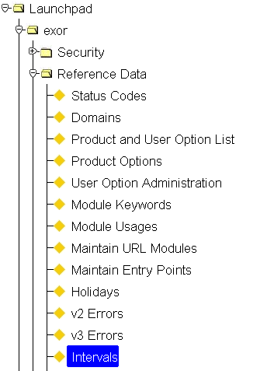
Interval Codes - HIG1220
Figure 4
Interval Codes
Menu option

Figure 5
Interval Codes
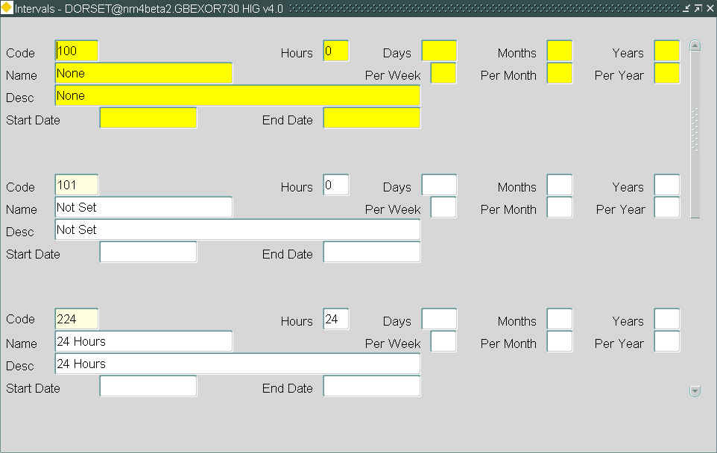

The system contains information about activities which take place at scheduled frequencies, e.g. 3 times per year, or within a pre-determined time period, e.g. 6 months. These frequencies and intervals are recorded in terms of Interval Codes.
You should set up interval codes in accordance with the standard interval codes defined by the DoT. These intervals are set up for all routine activities. Use this module to create new interval codes and update existing ones.
You cannot delete interval codes that have associated records and only one interval may be associated with each interval code.
Intervals
When you enter this window, select [Execute Query] to retrieve existing codes.

Code (Required)
Enter a unique interval code. This will identify the interval or frequency when using other forms.

Name (Required)
Enter the name of the interval code.

Desc (Optional)
Enter a full description of the interval or frequency.

Hours (Optional)
If the frequency is a multiple of hours, enter the number of hours in this field.

Days (Optional)
If the frequency is a multiple of days, enter the number of days in this field.

Months (Optional
If the frequency is a multiple of months, enter the number of months in this field.

Years (Optional)
If the frequency is a multiple of years, enter the number of years in this field.

Per Week (Optional)
If the frequency is certain number of times per week, enter the number of times in this field.

Per Month (Optional)
If the frequency is certain number of times per month, enter the number of times in this field.

Per Year (Optional)
If the frequency is certain number of times per year, enter the number of times in this field.

Start Date (Optional)
Enter the date the code is valid from. If blank, then this code is currently valid.

End Date (Optional)
Enter the date the code is valid to. If blank, then this code is currently valid.
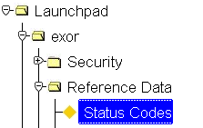
Defect Status Codes - HIG9110
Figure 6
Status Codes
Menu Option

During a defects life cycle it will automatically pass through a number of status code changes from when it is loaded onto the system to when the repair is completed on a works order.
Defect status codes are set up and maintained using Status Codes - HIG9110 as shown below.
Figure 7
Defect Status Codes
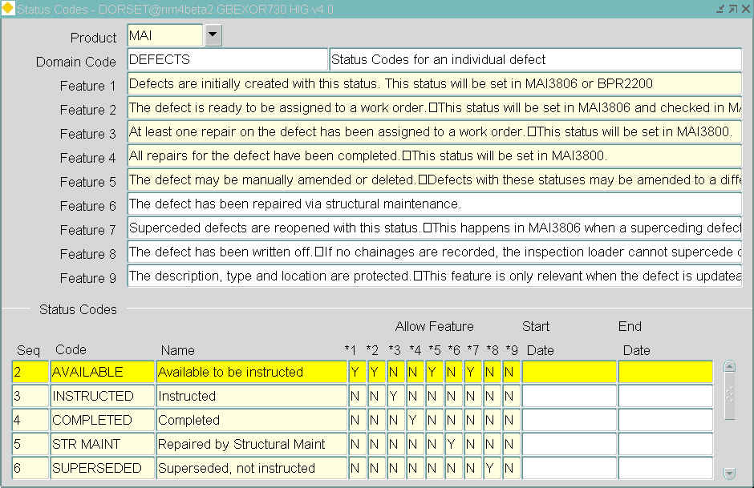

These are generally maintained by the system administrator. A default set of status codes are supplied with the system but they can be configured to suit each organization’s business processes, if necessary. When a new status code is added one or more of the following features may be applied.

Feature 1: Defects are initially created with this status. This status will be set in Inspections - MAI3808 or Load Bulk Inspections - MAI2200.
Feature 2: The defect is ready to be assigned to a work order. This status will be set in Inspections - MAI3808 and checked in Works Orders - MAI3800.
Feature 3: At least one repair on the defect has been assigned to a work order. This status will be set in Works Orders - MAI3800.
Feature 4: All repairs for the defect have been completed. This status will be set in Works Orders - MAI3800.
Feature 5: The defect may be manually amended or deleted. Defects with these statuses may be amended to a different status, providing it is also allowed with feature 5.
Feature 6: The defect has been repaired via structural maintenance.
Feature 7: Superseded defects are reopened with this status. This happens in Inspections - MAI3808 when a superseding defect is deleted.
Feature 8: The defect has been written off. If no chainages are recorded, the inspection loader cannot supersede defects, so they have to be written off. This may be set manually in Inspections - MAI3808 or automatically from Works Orders - MAI3800 (by setting the work status to NOT DONE).
Feature 9: The description, type and location are protected. This feature is only relevant when the defect is updateable (i.e. feature5 = Y).

If a status code ceases to be required the end date must be set, it must not be deleted for historical reasons.

Configuring and Entering Network and Asset (Inventory) Data
Typically, MM assigns work orders against sections of a road network; therefore, establishing and configuring a road network is generally a prerequisite to using Maintenance Manager. Although the road network will normally be established by someone other than those using MM, MM users should have an understanding of how the network is configured and the naming conventions used for sections and “levels” of the network. To learn more, see the Network Manager Admin and User’s manuals.
In previous versions of Maintenance Manager, the network(s) and inventory register were created and maintained through Maintenance Manager. In version 3 or later of highways by exor , Networks and Inventory (assets) are configured and entered though the Network Manager application (See the Exor Network Manager Systems Administration and User Guides). Prior to configuring Maintenance Manager the System Administrator must fully understand the network configuration and the assets, attributes and types of inventory placed on that network.

CHAPTER
3
Financial Reference Data
Maintenance Manager provides a complete financial capability to establish budgets, price work, maintain contract costs, compare costs of various methods of job accomplishment, track costs against budgets, properly assign costs to cost centres and maintain control over project approval. Before financial information can be entered, the Financial Reference data must be properly configured.

This chapter describes the forms used to create, maintain and review Financial Data. These forms are accessed under the “Reference” main menu, through Fastpath or through Favourites, both of which are located under the File Menu. These forms are:

- Job Size Codes - MAI3666
- Item Code Breakdowns - MAI1940
- Cost Centre Codes - MAI3844
- VAT Rates - MAI3846
- Budgets – MAI3660
- Generate Budgets for Next Year – MAI3662

Other Financial forms are accessed through the financial main menu header. These forms contain information that changes on at least an annual basis. These changes are made by the appropriate user and are discussed in the Maintenance Manager User Manual.

Figure 8
Financial Reference Data
Menu Options

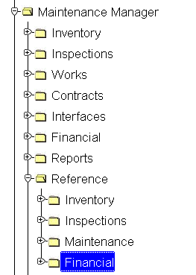

Job Size Codes - MAI3666
Figure 9
Job Size Codes
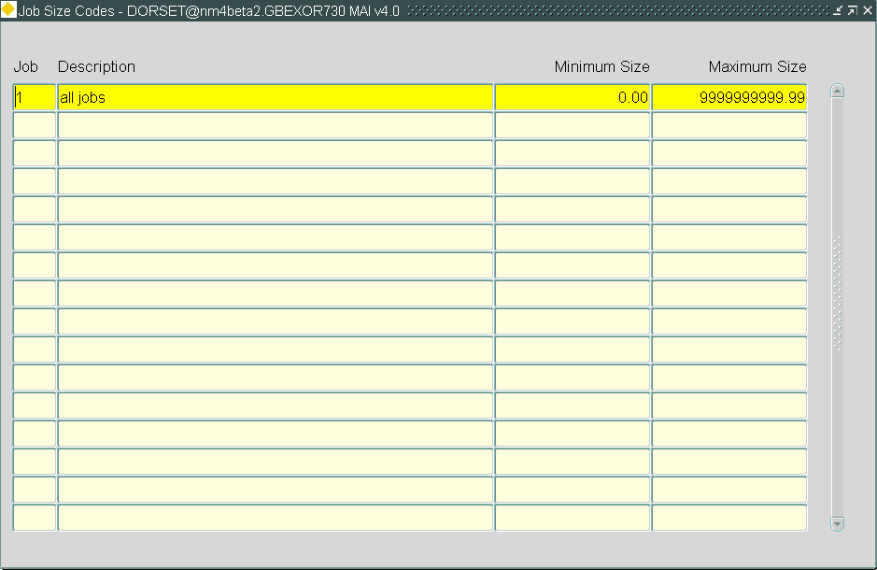

This module allows you to set up a series of bands that will show a commitment to a budget with the same road group / Sub-Sub-Item code combination based on the cost of the works order.
Job Size Codes
When you enter this window the cursor sits in the Job field waiting for you to enter a value.

Job (Required)
Enter an alpha-numeric code that identifies a job size.

Description (Required)
Enter a description of the job size code.

Minimum Value (Required)
Enter the minimum value of the job size.

Maximum Value (Required)
Enter the maximum value of the job size.
The minimum and maximum values must be contiguous and must not overlap.
Item Code Breakdowns - MAI1940
Figure 10
Item Code
Breakdowns
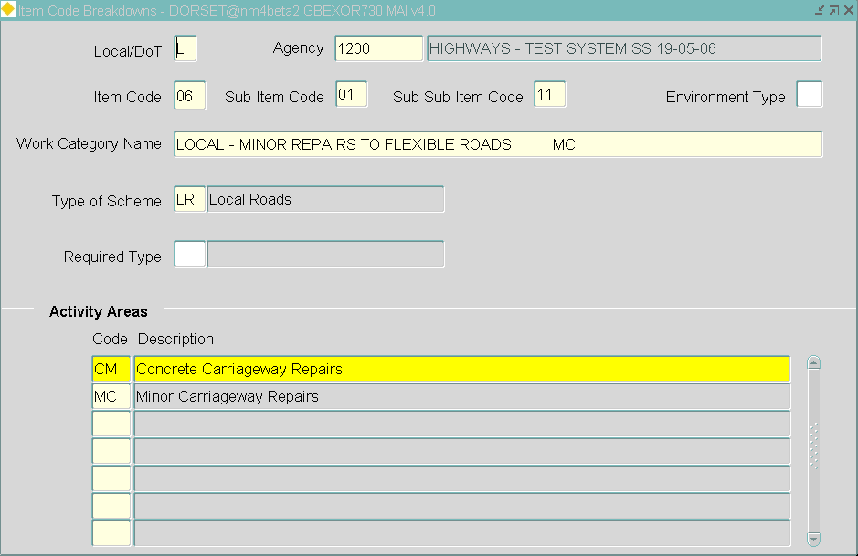

The Item Code, Sub-Item code and Sub-Sub-Item Code can be used to track budget expenditures by Type of Scheme (project), Type of Inventory and Type of Work, respectively. These Sub-Sub-Item codes are used as a unique six character budget heads against which work is carried out and budgets can subsequently be reported on. This will allow the cumulative expenditure on each Sub-Sub-Item to be compared against each budget allocation.
New codes can be assigned at any time; this can be used in conjunction with the other works facility to create a budget code to raise work against. However, it is best to set up as many codes as will be required during the initial configuration. To do so, it is usually helpful to set up a matrix.
Item Code Breakdown
When you enter this window, the cursor sits in the Item Code field waiting for you to input new data. Press [Execute Query] to retrieve existing details.
Use the Item Code Breakdown block to determine the breakdown of Item Codes to Sub-Item Codes and finally to Sub-Sub-Item Codes.

Local/DoT (Required, Default)
Whether this flag should be set to “L” or “D” can be determined from the network configuration.

Agency (Required, Default) List
Enter the Agency Code that will be used for this item type. Default is the standard agency code.

Item Code (Required)
Enter the Item Code of either ‘01’ - Renewed Scheme, ‘02’ - Road Scheme or ‘08’ - Summary Schemes for DoT roads. For Local roads any number apart from those used by the DoT are allowed.

Sub Item Code (Required)
Enter the Sub Item Code, which limits the above scheme to a specific item of inventory, e.g. 01 represents Minor Carriageway repairs.

Sub Sub Item Code (Required)
Enter the Sub-Sub-Item Code that is used to identify the type of work required, e.g. 01 represents Flexible Urban work.

Environment Type (Optional)
Enter the section’s environment. Valid values are ‘U’- Urban, ‘R’ - Rural and ‘S’ - Suburban or leave blank for Urban/Suburban/Rural sections.
These values are set up and maintained using Domains - HIG9120 and updating the ROAD_ENVIRONMENT option.

Work Category Name (Required)
Enter a descriptive name of the type of work that applies to the item code breakdown above.

Type of Scheme (Required, Default) List
Enter the type of scheme that will use the selected item code. This is important when raising a works order because once a scheme type is selected the user is restricted to selecting only the item codes that have been associated with it.
These values are set up and maintained using Domains - HIG9120 and updating the SCHEME_TYPES option.
Additional scheme types such as Structural Maintenance, Bridge Maintenance etc. may be added to suit your operational requirements.

Required Type (Optional) List
Enter either ‘L’ - Length, ‘A’ - Area or ‘N’ - Number. A description will be displayed in the adjacent field.
Activity Area
Activity Areas are tied to Item Code Breakdowns; this will assign the activity to a budget header for use when raising a works order.
When raising a defect clearance works order, a work category (item Code Breakdown) is selected and since defects are associated to activities using Defect Control Data - MAI1300, only defects of the relevant type will be retrieved on the works order and allocated to a budget.

Area (Required) List
Enter an existing activity code.

Description (Display Only)
The description that corresponds to the activity area value of the previous field will be displayed.
Cost Centre Codes - MAI3844
Figure 11
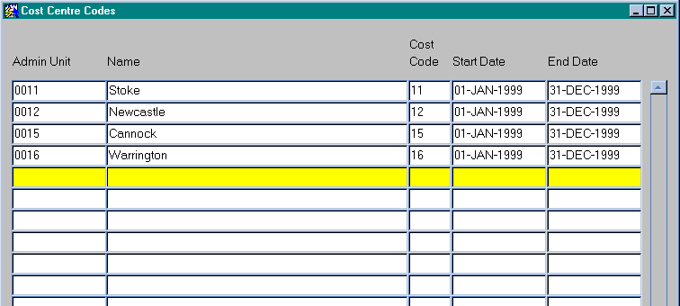
Cost Centre Codes

This module is used to define the cost centre codes that may be used when raising a works order. These can only be reported on if you have an external reporting tool. The codes are for reference only and are not referenced elsewhere on the system.
Cost Centre Codes
Admin Unit (Required) List
Enter the admin unit to which this cost code will apply. A description will be displayed in the adjacent field.

Cost Code (Required)
Enter a unique cost code.

Start Date (Required)
Enter the start date from which this cost code will apply.

End Date (Required)
Enter the end date to which this cost code will apply.
VAT Rates - MAI3846
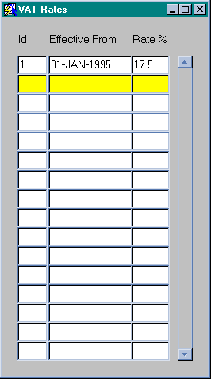
Figure 12
VAT Rates

This module is used to define the various rates of Value Added Tax (VAT) or other sales tax in force at any time, if any. The VAT rates are used in a number of reports throughout the system.
VAT Rates
Id (Required)
Enter a serial number to uniquely identify this VAT rate.

Effective From (Required)
Enter the date from which this rate is applicable.

Rate % (Required)
Enter the percentage VAT rate.
Budget Maintenance

Within Maintenance Manager it is possible to hold budget information for use against defect, small scheme or cyclic Works Orders. A work category (budget code) is set up and can be held against any number of road groups to suit the organization’s network structure. An organization budget code can be applied to each budget so reports can be run to reflect the current financial situation against either the work category or the organization’s internal code.
When creating a works order a user is able to see the amount of the budget that has been spent to date before selecting each work category. Each time a works category is assigned to a works order the amount is then committed to the budget. This provides a very powerful budgeting tool.
Maintenance Manager can also hold standard items and contract rates for any given number of activities. Contracts can be applied to a whole network or restricted to a particular area, if required comparisons can be made between contracts for the pricing of work through the ‘Works Order’ screen (covered in the Maintenance Manager – Works Orders document) and restrictions can be set against the quantities applicable to standard items when using them on a works order.
The system is supplied with standard United Kingdom Department of Transport meta-data; however, data can be created to reflect an organization’s method of working should the meta-data not be suitable. Prior to an organization using it’s own work category (budget) codes, they must first be set up within Maintenance Manager.

Budgets - MAI3660
Figure 13
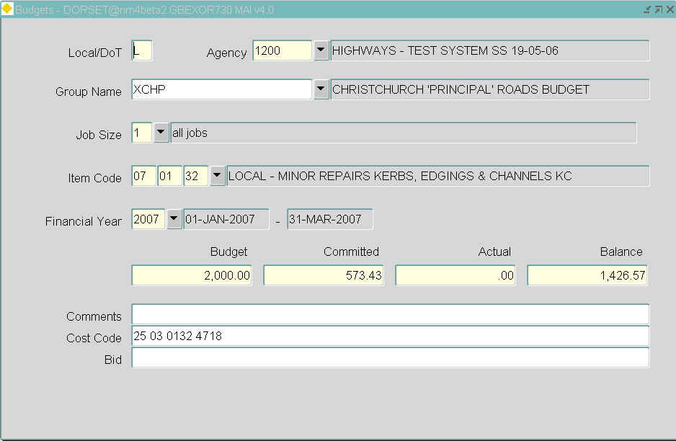

This form is used to create cost codes to be used for budgeting purposes.
Works orders can be raised for multiple budgets through selection of different work categories; therefore an individual works order could be carried out with work on Carriageway, Kerbing and Footway activities at the same time whilst the budget allocation will be taken from separate budgets.
A works order can be identified as being against a specific Budget or Budgets because all works orders are raised against a selected work category (Sub-Sub-Item code) and Road Group.
Budgets can be allocated and maintained using Road Groups, a Budget can be set up against a Road Group and any work carried out on Road Sections within the selected Road Group will show a commitment against that Budget.
If a Budget is set up with no associated Road Group any work raised against the selected work category will show a commitment against the Budget.
The current Budget position can be quickly viewed using this form. As Works Orders are raised against the Work Category associated with a Budget, the 'Committed' Value (i.e. the estimated amount on a Works Order) will be displayed. When Works Orders are included on a payment run the Committed values become 'Actual' Values and the Balance for the Budget is calculated and displayed. Once the allocated amount is reached no further Works Order lines may be added to any Works Orders except if the User creating the Works Order has been granted the Role OVER_BUDGET. This role allows a User to raise Works Orders greater than the maximum value of the budget used.
To enter an unlimited budget, set the Budget to –1.
If no budget has been set up, a commitment will still be shown when the budget reports are run.

Budgets
When you enter this window the cursor sits in the Local/DoT field waiting for you to enter a value.

Local/DoT (Required)
This identifies whether it is an ‘L’ (Local) or ‘D’ (DoT) budget.

Agency (Required) List
Enter the maintaining agent for the road group for this budget. The full name will appear in the adjacent field.

Group Name (Optional) List
Enter the road group to which this budget applies. Sections that appear on works order lines should correspond to sections within one of these groups. A description will appear in the adjacent field.

Job Size (Required) List
Enter the Job Size code for this budget, e.g. how big was the works order. The job size does not apply to DoT work. If DoT is selected in the previous fields, a value of 0 will be displayed in this field. A description will appear in the adjacent field.
These codes will have been set up using Job Size Codes – MAI3666.

Item Code (Required) List
Enter the Item Code, Sub Item Code and Sub Sub Item Code for this budget. This specifies the work category that is entered on a works order. Each authority will have set up their Sub Sub Items for their local roads in addition to the default values supplied by the DTp for their own roads. These codes will have been set up by using Item Code Breakdowns – MAI1940. A description will appear in the adjacent field. These item codes can be reported on using Print Budget Exceptions – MAI3690.

Financial Year (Required) List
Enter the financial year for this budget. The range of the financial year will be displayed in the adjacent two fields. These are set up by using Financial Years – HIG3664. Therefore, given any works order you will know which financial year the works order applies to.

Budget (Required)
Enter the amount of money allocated to this budget.

Committed (Display Only
The total value of work Instructed on associated Works Orders will be displayed.

Actual (Display Only)
The Actual total value of work carried out will be displayed

Balance (Display Only)
The Balance remaining for the Budget will be displayed.

Comments (Optional)
Enter any additional comments.

Cost Code (Optional)
Enter an external cost code which represents this budget. This could be used for interfacing with other systems if required.
Cost codes allow you to enter your own internal budget codes if required; a number of different budgets could be assigned the same cost code.
If Naris or Lafis codes are used they can be entered here.
These cost codes can be reported on using Print Cost Code Exceptions. (See the Users’ Manual)

Bid (Optional)
This field will only be displayed when the product option DISPBID is set to ‘Y’.
The Contractor Interface Module appends the contents of this field onto the end of the works order line field when the works order extract is carried out when creating the wor file.
This will only be used when the hig option 'XTRIFLDS' = '2-4-0'
Generate Budgets for Next Year - MAI3662
Figure 14
Generate Budgets
For Next Year

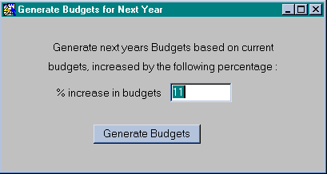
General Information
This form has only one field. In this field you can enter a percentage figure. This will generate next year’s budgets based on the current budgets by the percentage given. This percentage can be a negative figure if required.
It will take the information from Budgets – MAI3660 and multiply the allocated amount by the percentage-entered incrementing the financial year to create the following year’s budgets.
This uses the system clock to calculate the year so if you have passed into the next financial year the date will need to be reset to carry out this procedure. All this current years sub sub item codes will be used for the next years budgets.
The next financial year mist have been previously set up in Financial Years – HIG3664.

CHAPTER
4
Maintenance Reference Data
Maintenance Manager identifies work requirements through “Inspections” and describes the required work through the concept of “Defects.” This chapter describes the forms used to create, maintain and review Inspections, Defects and Treatments to correct Defects. They are the following forms:

- Activities - MAI1200
- Activity Groups - MAI1205
- Local Activity Frequencies - MAI1210
- Default Section Intervals - Calculation - MAI1230
- Default Section Intervals - Override - MAI1240
- Valid for Maintenance Rules – MAI3440
- Related Maintenance Activities – MAI3628
- Cyclic Maintenance Inventory Rules – MAI3626
- Work Order Auditing – MAI3803
- Asset Activities – MAI3632
- Budget Allocations – MAI3630
- Work Order Priorities – MAI0132

Figure 15
Maintenance Reference Data
Menu Options

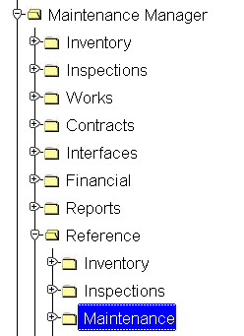
Activities - MAI1200
Figure 16
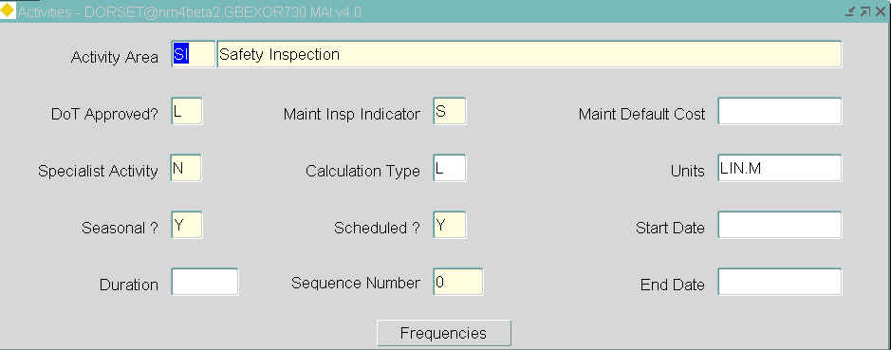

This form is used to associate default response times, frequencies intervals and Durations for new activities and to alter defaults for existing activities.
New activities can also be entered here to suit your requirements, examples of which may be Street Cleansing, Refuse Collection, Tree Inspections etc.
The system must contain the information regarding the activities which take place at scheduled frequencies (e.g. 3 times per year) or within a pre-determined time interval (e.g. 6 months) and the Duration of the Activity. The frequencies and intervals are recorded in terms of interval codes using the second window of this form.
Having defined the activities they will need to a series of defects associated to each activity, this is carried out using Defect Control Data – MAI1300.
For budgeting purposes Activites need to be associated to cost codes using Item Code Breakdowns - MAI1940.
Activities
When you enter this window, press [Enter Query], enter your selection criteria and press [Execute Query].
This window is used to associate general information against each activity.

Activity Area (Required)
Enter a valid activity area code. If a new activity area is being entered you will need to move to Item Code Breakdowns - MAI1940 to specify the relationships between the item codes and the activity area prior to using works ordering and budgets.
Enter a description of the activity area in the adjacent field.

DoT Approved? (Required, Default)
Enter ‘D’ or ‘L’. These identify whether the activity has been determined by the DoT or the Local authority. The default value is ‘D’.

Maint/Insp Indicator (Required)
Enter ‘D’, ‘S’ or ‘M’ representing Detailed Inspection, Safety Inspection and Cyclic Maintenance respectively. For specialist activities enter 'U' for user defined.
If 'D' or 'S' is selected the activity will be included in the Default section Intervals Calculations – MAI1230. If set to ‘M’ it will not appear as an option when selecting the activities when carrying out an inspection.

Maint Default Cost (Optional)
This field is used in either cyclic maintenance or user defined activities. Enter the default cost per unit for the activity.

Specialist Activity? (Required, Default)
Enter ‘Y’ if this activity is a specialist inspection. Otherwise the default value of ‘N’ is valid.

Calculation Type (Required) List
A calculation type must be entered for a cyclic maintenance activity, use Trapezium rule to calculate areas.
These calculation types are set up using Domains - HIG9120

Units (Optional) List
The units for this calculation can be entered.
These values can be added to using Domains - HIG9120 and updating the ATV_UNIT option.

Seasonal? (Required)
Enter ‘Y’ for a seasonal activity, i.e. a frequency, or enter ‘N’ for an activity that is not seasonal, i.e. an interval. For example, you may cut the grass twice per year but on both occasions it will be during the summer.

Scheduled? (Required, Default)
Enter either ‘Y’ or ‘N’ to indicate whether or not the frequency or interval is controlled.

Sequence Number (Required)
Enter a number which indicates the order in which the activity will be either
printed or displayed.

Duration (Optional)
Enter the planned duration of the activity.

Start Date (Optional)
The date the code is valid from. If blank, then this code is currently valid.

End Date (Optional)
The date the code is valid to. If blank, then this code is currently valid.
Figure 17
Frequencies Button
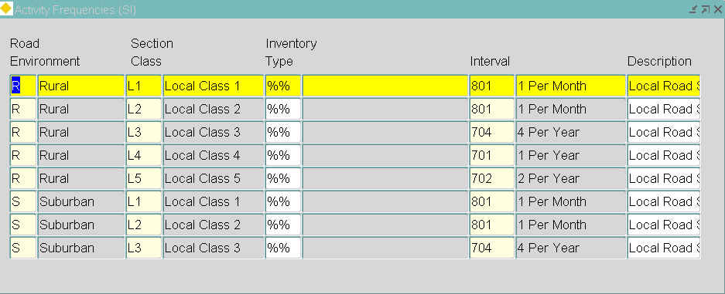

Frequencies Button

Selecting the [Frequencies] button displays the current frequency or interval (the frequency is every 12 months or once each year) for the selected activity. These intervals were defined in Interval Codes – HIG1220.
Whilst the activity frequency is commonly associated to the inventory on the road section, if no inventory exists the Inventory Type field can be left blank, in this case the activity will be scheduled on all sections irrespective of the inventory in those sections.
For all routine activities (Inspections and Cyclic Maintenance), the DoT lays down a set of standard intervals and frequencies for their performance. For example, an agent may be obliged to clean street lamps every two years or change lamps every eighteen months. The timescales can be different depending on the activity, the type of inventory concerned, the class of road (Motorway, A road etc.) or the roads’ environment (Rural, Urban, Suburban).
Once these frequencies and intervals have been entered they must be applied to the road network using Default Section Intervals – Calculation – MAI1230.
The default frequencies and intervals for an individual road section can be overridden using Default Section Intervals - Override.- MAI1240
These frequencies and intervals can be further modified within a section if required using Local Activity Frequencies – MAI1210.

Road Environment (Required) List
Enter the road environment for this activity. A description will be displayed.

Section Class (Required) List
Enter the section class for this activity. A description will be displayed.

Inventory Type (Optional) List
If entered, the system will only schedule the activity on road sections which contain inventory of this type. A description will be displayed in the adjacent field.
If '%%' is entered in this field, the activitiy will be scheduled on ALL sections irrespective of the inventory in those sections, this is commonly used on Safety Inspections.
The inventory types must already exist and will have been set up using Inventory Control Data - MAI1400.

Interval Code (Required) List
Enter the interval code for the frequency or interval at which you require the activity to be carried out. A description will be displayed in the adjacent field.
These values are set up using Interval Codes.

Description (Optional)
Enter a description of the activity frequency.
Activity Groups - MAI1205
Figure 18
Activity Groups

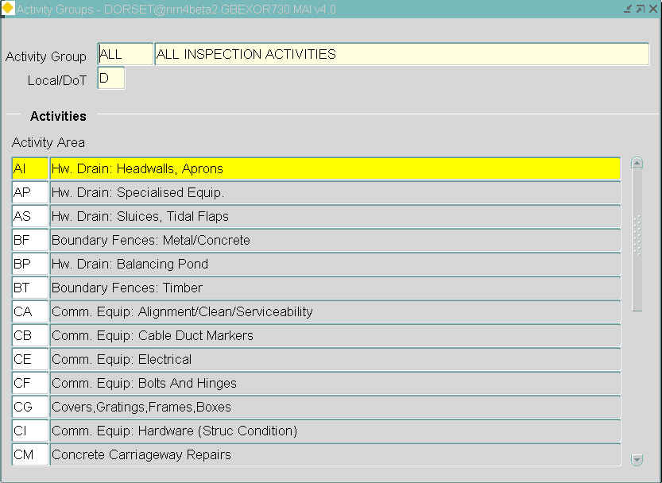

This form is used to set up and maintain groups of activity areas. It is mainly used for reporting purposes.
Activity Group
When you enter this window either press [Execute Query] to retrieve existing activity groups or press [Create Record] to enter a new one.
Use the Activity Group block to define the group name or retrieve an existing group.

Activity Group (Required)
Enter a name for the activity group you are creating and a description in the adjacent field.

Local/DoT (Required, Default)
Enter either 'L' if the activity group is to be used on local roads or 'D' for DoT roads.
Activities
Enter the activities that will form the required activity group.

Activity Area (Required) List
Enter an activity and its description will be displayed in the adjacent field.
Local Activity Frequencies - MAI1210
Figure 19
Local Activity
Frequencies

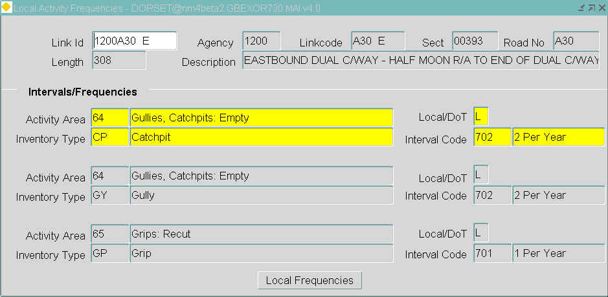

This form allows you to go one step further in defining the frequencies and intervals of an activity within a section. You can specify a number of different interval codes for the same activity ‘locally’ within a section by specifying start and end chainages. One reason for using local frequencies is if a particular item of inventory is older than usual. For example, an old model of a street light may need cleaning more frequently than its newer counterpart.
Section Details
When you enter this module, the cursor sits in the Link ID field waiting for you to enter your selection criteria followed by [Execute Query] to obtain the section for which you wish amend the local frequencies.
The following fields are query only:
- Link ID
- Agency
- Linkcode
- Section
- Road Number
- Length
- Description
Interval/Frequencies
The existing intervals and frequencies for each activity area will be displayed. These are the default values and cannot be updated here. Select the [Local Frequencies] button to add local frequency details.
The following information will be displayed:
- Activity Area
- Inventory Type
- Interval Code
- Local/DoT
Local Frequencies Button
Selecting the [Local Frequencies] button at the bottom of the Local Activity Frequencies form raises the following:
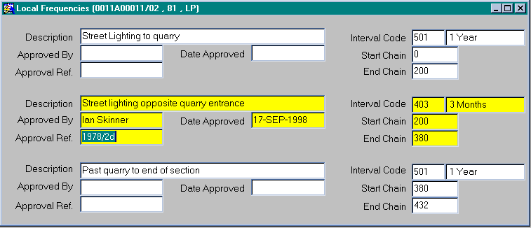
Figure 20

Enter details of the local frequency using this window.

Description (Optional)
Enter a description for the interval code change.

Interval Code (Required) List
Enter the interval code to which you require the activity to be performed.

Approved By (Optional)
Enter the name of the person who approved the new Interval/Frequency
code.

Approval Ref (Optional)
Enter the approval reference number.

Date Approved (Optional)
Enter the date on which the Interval/Frequency changes were approved.

St Chain (Optional, Default)
Enter the chainage at which you wish the new Interval/Frequency to begin. The default value is 0.

End Chain (Optional, Default)
Enter the chainage at which you wish the new Interval/Frequency to end. The default value is the end chainage for the section.
Note. The sum of the chainages must equal the total chainage as shown above.
Default Section Intervals Calculation - MAI1230
Figure 21
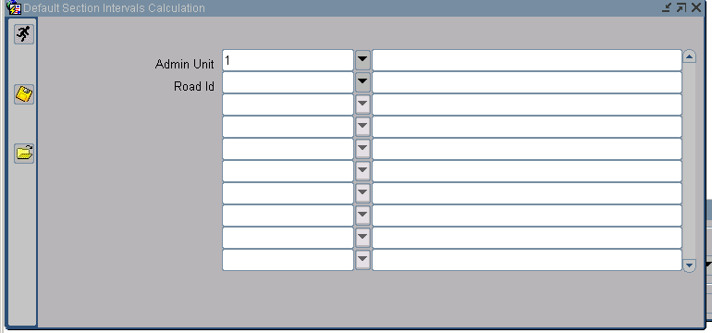

This option is used when one of the following has been carried out:
load network or add new network
load inventory or add new inventory types onto your network
add additional activities
This option is used to set the intervals and frequencies for activities that need to be carried out on the inventory that exists on the road network, as well as a basis for scheduling inspections on that inventory.
The frequencies and intervals calculated using this option can be modified in three ways:

- If the default intervals or frequencies for activities carried out on inventory items on the road network change, you can modify the default values that will apply when each option is run. This is done using Activities – MAI1200
- The intervals or frequencies for activities carried out on inventory items on individual sections can be altered using Default Sections Intervals – Override – MAI1240
- If it is required that the intervals or frequencies for activities carried out on inventory items be changed locally within an individual sections, i.e. three verges at different chainages within the section need cutting more frequently than the rest of the verges within the section, you can use Local Activity Frequencies – MAI1210

If you need to rerun an intervals calculation because a default frequency has changed or a new inventory item has been added, the changes that were made to the frequencies or intervals of individual sections or locally within individual sections will not be affected.
This module uses the Generic reporting Interface (GRI).

Parameters
Admin Unit (Required) List
Enter the admin unit for which you want to run the intervals calculation.

Road Id (Required) List
The default section intervals section calculation can be run at any level within your gazetteer hierarchy. Enter a road group or section against which you wish the process to run.

Default Section Intervals - Override - MAI1240
Figure 22

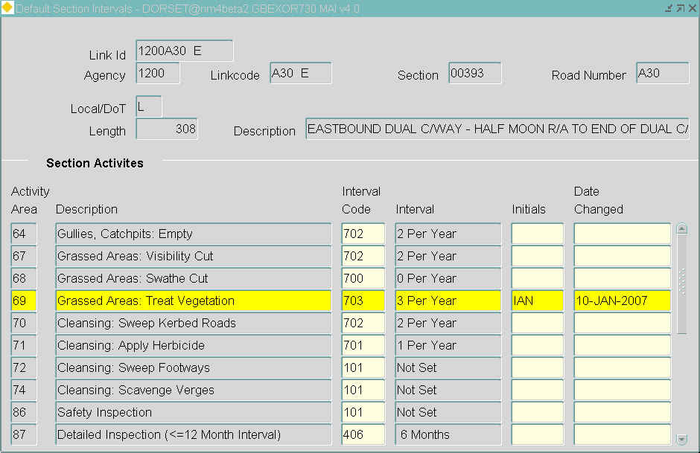

Use this option to override the values created using Default Section Intervals Calculation – MAI1230
Section Details
When this form is openned, the cursor sits in the Link ID field. After entering the selection criteria into the field(s) shown in the following list, click [Execute Query] from the header menu to obtain the section for which you wish to view or amend the intervals.
The following fields are query only:
- Link ID
- Agency
- Linkcode
- Section
- Road Number
- Local/DoT
- Length
- Description

Section Activities
Existing activities for the selected section will be displayed.
You cannot create section frequencies here, you can only modify the interval code and initials details.

Act Area (Display Only)
The activity area for the section will be displayed.

Description (Display Only)
A description of the activity code will be displayed.

Interval Code (Required) List
Enter an existing interval code. If the activity code is seasonal then the interval code must relate to a frequency, e.g. twice a year, otherwise it will relate to an interval.
These values are set up using Interval Codes – HIG1220.

Interval (Display Only)
The interval description will be displayed.

Initials (Required)
When you update an interval you must enter your initials in this field before the changes can be committed to the database.

Date Changed (Display Only)
The date the interval was changed will be displayed.

Valid for Maintenance Rules - MAI3440
Figure 23

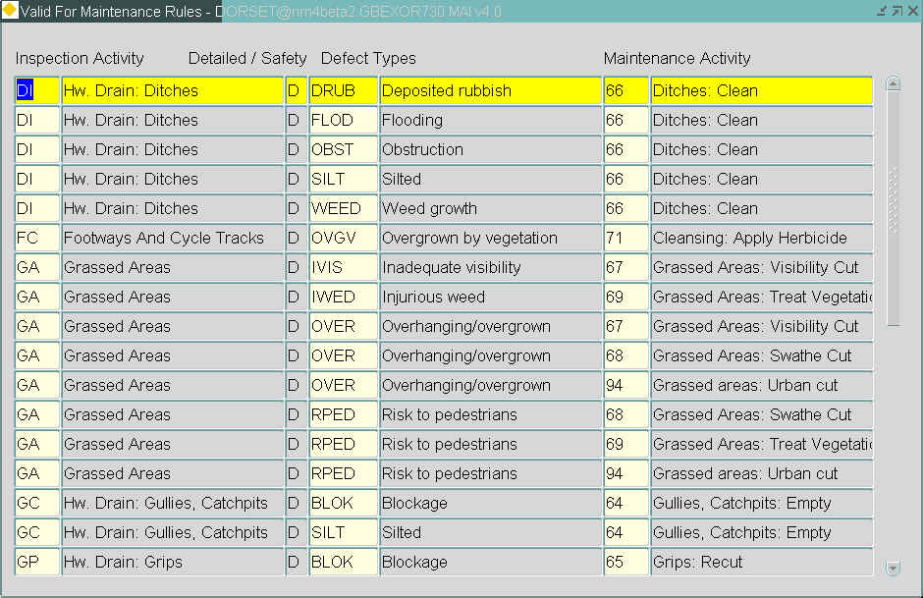

This form allows you set up the rules that define when a cyclic maintenance activity will clear a defect that was loaded as a result of a regular or ad hoc inspection.
For example, an inspection activity of GA (Grassed Areas) could result in a defect of type IWED (Injurious Weed), this in turn would be cleared when the cyclic maintenance activity 69 (Grassed Areas : Treat Vegetation) is carried out on the sections.
A standard set of rules are supplied with the system, these can be added to if required.
Valid for Maintenance Rules

Inspection Activity (Required) List
Enter an inspection activity. These activities are set up using Activities - MAI1200.
A 'D' or 'S' will be displayed in the adjacent field indicating whether the activity is used in detailed or safety inspections.

Defect Types (Required) List
Enter a defect type. These defects are set up using Defect Control Data - MAI1300.

Maintenance Activity (Required) List
Enter a maintenance activity. These activities are set up using Activities - MAI1200.
Related Maintenance Activities - MAI3628
Figure 24
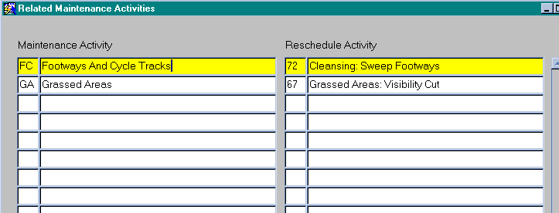

This form is used to reschedule cyclic maintenance activities when work has been carried out on a section that has an affect on that activity. For example, removing old signs along a carriageway and replacing them with new signs could result on the regular activity of sign cleansing being rescheduled.
These activities are set up and maintained using Activities - MAI1200.

Maintenance Activity (Required) List
Enter a maintenance activity. This activity will have been previously linked to a works category using Item Code Breakdowns - MAI1940. Prior to being selected for use when raising a works order.

Reschedule Activity (Required) List
Enter the activity that is to be rescheduled when the above activity is carried out on a section.

Cyclic Maintenance Inventory Rules - MAI3626
Figure 25

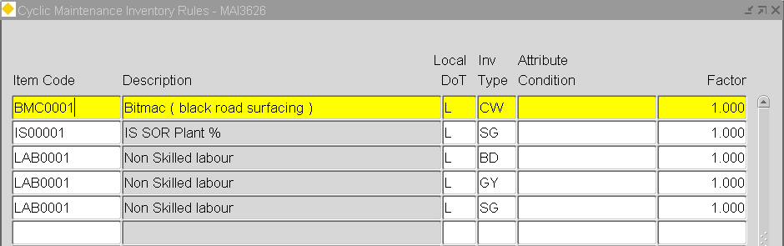

When a cyclic maintenance works order schedule is set up it looks at the data within this form to work out the quantity of work to be done based on the inventory contained on the selected sections
Before cyclic maintenance works orders can be generated from the system, a set of rules for each type of inventory to be included must be created. These rules determine which inventory types will be affected when each of the standard jobs are carried out.
If no inventory exists on the sections and the actual values are to be entered using Cyclic Maintenance Schedules by Section no rules need entering.
Cyclic Maintenance Inventory Rules
When you enter this window the cursor sits in the Loca/DTp field waiting for you to enter new data. To obtain existing data press [Execute Query] from the toolbar.

Item Code (Required) List
Select a valid job item from the List of Values to represent the work.

Description (Display Only)
A description of the item code will be displayed.

Local/DoT (Required) List
Enter ‘L’ for Local, ‘D’ for DoT inventory.

Inv Type (Required) List
Select a valid inventory item type to represent the inventory which the current job item acts upon.

Attribute Condition (Optional)
If required, enter a logical condition to restrict the inventory affected by the current job item. This field is used to be more selective with the inventory item and can limit the work to inventory of a given type. It is populated with the inventory item 'Column Name' and 'Attribute Values' which can be established from Inventory Control Data - MAI1400. For example, for grass cutting on an embankment where the angle of the embankment required is less than 45º the Attribute condition would be: IIT_ANGLE < 45

Factor (Optional)
Enter a factor if the contract rate is charged on a different unit of measurement to the unit the inventory item is normally measured in.
For example, a verge is measured in metres but the SOR price may be priced per kilometre, in this case a factor of 0.001 can be applied converting the verge length from metres to kilometres.

Works Order Auditing Maintenance - MAI3803
Figure 26

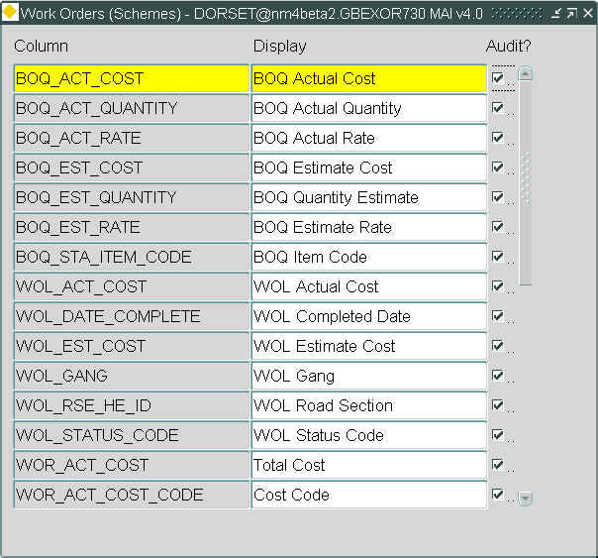

his read only form is used to define which fields on a Works Order are included in the Audit Trail Log. The changes made to this form will affect the Audit Trail Log for all Users, i.e. the form is not User specific.
Work Order Audit Maintenance
When you enter this form, press the [Execute Query] button to query back the allowable fields, which may be audited.
The Oracle Table Column name and the displayed name will be displayed. To select a column to be audited on a Works Order, click in the 'Audit?' check box. A tick will be displayed signifying that the column has been selected. To de-select a column click in the 'Audit?' check box. The tick will be removed and the column will not be audited in future Works Order Changes.

The Auditing can be viewed when in Works Orders – MAI3800 and selecting the [Expand] button.

Additional works ordering facilities are available using the AUDIT_ALL product option.
Asset Activities – MAI3632
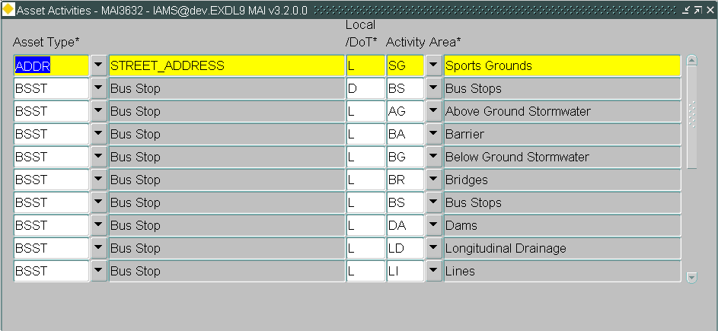
Figure 27

General Information
This module is used to associate Off Network Asset Types with Maintenance Activities Areas, which allow Defect Types to be validated and restricted to a given Asset Type. The Asset Type/Activity Area combinations defined within this module are used when creating Defects against Assts from the Map Window of Locator (refer to the Asset Manager User Guide). Only Activities associated with the selected Asset Type will be available when defining the Defect details. The list of available Defect Types will be validated against those Defect Types associated with the selected Activity Area.
An Asset Type may have many associated Activity Areas.
Activities and Defect Types are created and associated using Activities – MAI1200 and Defect Control Data - MAI100 respectively.
Asset Activities
To display existing data press [Enter Query], enter your selection criteria, followed by [Execute Query].

Asset Type (Required) List
Select the Asset Type for which to associate an Activity Area. This can include Asset Types where the Asset Item data does not reside within the Exor Database but is instead accessed using Exor external asset functionality. The Asset Description will be displayed in the adjacent field.

Local/DoT (Required)
Enter either ‘L’ or ‘D’ depending on whether the Activity Area is classified as a Local or DOT activity (consult your Exor Implementation or Services representative if in doubt as to what to enter for this field).

Activity Area (Required) List
Select the Activity Area to be associated with the selected Asset Type. The list of allowable Activities will be determined by the previously entered Local / DoT flag.
Budget Allocations – MAI3630
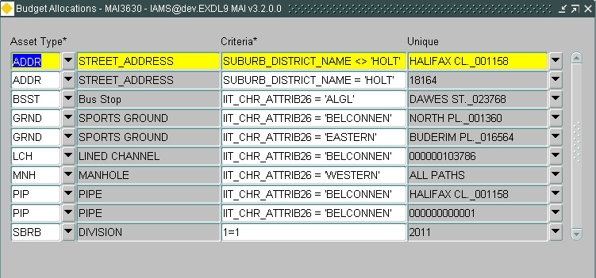
Figure 28

General Information
This module is used to define the reference data required when raising Defects and Inquiries against ‘Off Network Assets’, i.e. Assets that are not located on any Networks. This includes Asset Types for Items that are not stored within the Exor Database, but which are available via Exor external asset functionality (refer to the Asset Manager System Admin guide).
When Defect Work Order Lines are completed the Budget from which the Actual monetary amount is reconciled is determined by either the Network Section on which the Defect was raised (for Network based Defects) or by the Budget Allocation defined for an Asset using this module (for Off Network Asset based Defects).
This module allows an Off Network Asset Type to be associated with a ‘logical’ Network Section (this does not require a spatial representation), which has been created for the sole purpose of Budgetary Allocations. Budget Allocation Sections should then be added as members of an appropriate Group of Sections of the type specified for Product Options ‘BUDGRPTYPL’ and /or ‘BUDGRPTYPD’ depending upon how your system is configured.
Asset Items of a given Type can be assigned to different Budgets by defining a criteria string based upon a single Attribute of the selected Asset Type. For example, an Off Network Asset Type of ‘Park’ may have an Attribute of ‘District’. A separate Budget may exist for all work carried out within a given District. Defining a criteria string such as District=’BELCONNEN’ for the Asset Type/Budget Section combination would allow the work carried out on ‘Parks’ in ‘BELCONNEN’ to be assigned to a different Budget than work carried out on a Park in the District of ‘WESTERN’ for example.
If no Attribute restriction is to be placed upon an Asset Type / Budget Section combination, i.e. all work carried out on any Asset Items of the selected Type will be assigned to the same Budget Section, the criteria string should be entered as a ‘constant’ which evaluates to true, e.g. ‘1=1’.

Note that the Budget Section defined should be of a Network/Group Type defined within the Road_Segs translation view.
The Budget Section associated with an Off Network Asset is displayed on the Defects - MAI3806 and Inspections – MAI3808 modules in the ‘Road Section’ fields. When an Off Network Asset Defect is placed on a Work Order Line the Asset Details are displayed for information. If an enquiry is raised against an Off Network Asset the Budget Section is displayed as the ‘Road’ field on the enquiry form.

Budget Sections should be created using the Elements – NM0105 module.

Budget Allocations
To display existing data press [Enter Query], enter your selection criteria, followed by [Execute Query].

Asset Type (Required) List
Select the required Asset Type for the list of values. An Asset Type may be associated with many ‘Budget Sections’ (‘Unique’ field) if the ‘Criteria’ string is different for each combination. This allows for Items of the same Type to be assigned to different Budgets.
The Asset Type description will be displayed in the adjacent field.

Criteria (Required)
Enter the criteria string used to restrict Items of the selected Asset Type to the Budget Section. When defining the criteria the Table Column name used for the Attribute should be used, for example is the Asset Type is an Exor Asset, i.e. not an ‘External Asset’ the attribute Column Name may be IIT_CHR_ATTRIB26 etc.
If the Asset Type is an ‘External Asset’, i.e. the data does not reside within the Exor database, the column name used for the attribute within the external View/Table should be used.
If no Attribute restriction is to be placed on the Asset Type/Budget Section combination a constant value such as 1=1 may be entered. This will mean that the same Budget will be used for all Asset Items of the selected Type.

Unique (Required) Gaz
Enter the Unique (ne_unique) name of the Budget Section or select from the Gazetteer, which may be called by pressing the ‘Drop Down List’ icon adjacent to the field.
Note that the Budget Section defined should be of a Network/Group Type defined within the Road_Segs translation view.

Work Order priorities – MAI0132
Figure 29
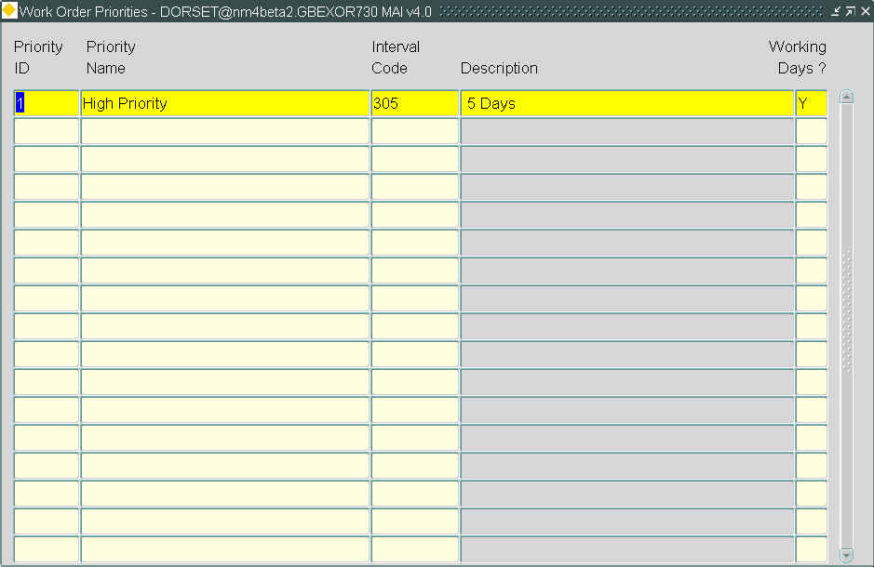

General Information
This module is used to define the priorities that will be used in Work Orders – MAI3800.
Priorities
Priority Id (Required)
Enter the priority Id.

Priority Name (Required)
Enter the priority description.

Interval Code (Required) List
Enter the Interval Code. This will have been previously defined using Intervals – HIG2220. A description will be displayed in the adjacent field.

Working Days (Required)
Enter either Y or N to indicate if working days are to be used.
CHAPTER
5
Inspection Reference Data
Inspections are normally performed using either map capture or data capture on a suitable Data Capture Device - DCD and the results of the inspections are loaded through an Inspections file. Before taking the DCD into the field, the inspector will upload metadata that is required to describe the inspection, record information about the road condition, or identify defects and their treatments. The following forms are used to maintain that metadata within the system.

- Organisations - MAI1870
- People - MAI1830
- Defect Control Data – MAI1300
- Defect Priorities – MAI3812
- Maintain Automatic Defect Prioritisation – MAI3813
- Treatment Data - MAI3814
- Default Treatments – MAI3150
- Enquiry / Treatment Types - MAI1320
- Enquiry / Defect Priorities - MAI1325
Figure 30
Inspection Reference Data
Menu Options
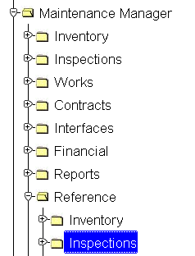

Organisations - MAI1870
Figure 31
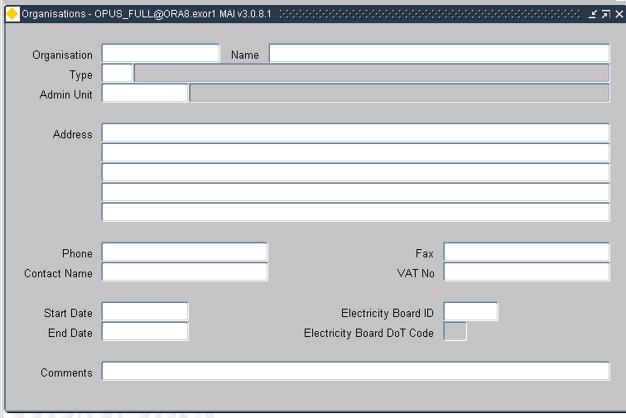

When activities are carried out on road sections by external organisations, they can be recorded within the system to enable engineers to assess the implications of any planned maintenance. For example, if the Gas Company plans to replace a gas main, it would show up in the system so that no major works are done on that part of the road until the Gas Company has completed its work.
Form MAI1870 is used to provide information about organizations that may affect the network and who may need to be contacted with regard to the work they are doing or work that will affect their operations. Information about those organizations is entered into the system using this form.
The fields on the form are self-explanatory. All fields are optional and only those that apply need be completed.

People - MAI1830
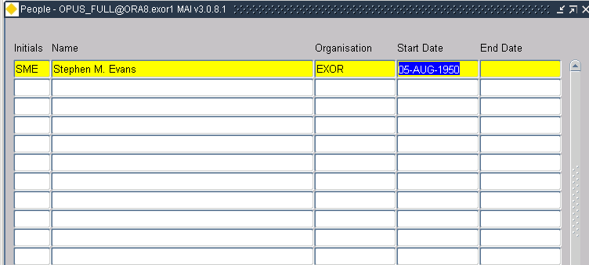
Figure 32

The Inventory form includes an entry to identify the Primary and Secondary inspector. This form is used to manage qualified inspectors and to populate the LOV on the Inspection Form.
The fields on the form are self-explanatory. Only the initials and Name fields are mandatory.

All users accessing the system should now be set up with Users – HIG1832.

Defect Control Data - MAI1300
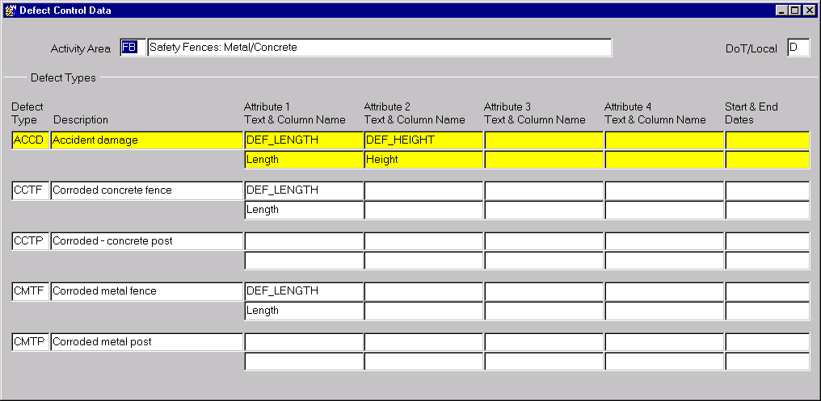
Figure 33

This form is used to set up and maintain standard defects and their inspectable attributes for an associated inspection activity. For example, the activity area RS (Road Studs) may have defect types such as MISR (Missing Reflector) and MISC (Missing Catseye).
Defect Control Data will be downloaded onto a DCD if required.
Defect Control Data
Activity Area (Required) List
Select the activity area that is to have associated defects. A description will be displayed in the adjacent field.

DoT / Local (Display Only)
'D' for DoT activities or 'L' for local activities will be displayed.
Defect Types
Enter the defect types with their required inspectable attributes for the associated activity.

Defect Type (Required)
Enter up to four characters for the defect code.

Description (Required)
Enter a defect description.

Attribute 1 Column Name (Optional) List
Enter the column name of the first attribute. This is used for the input of DCD files.

Attribute 1 Text (Optional)
A default description will be displayed for the attribute selected, this can be overtyped with a more meaningful description if required.

Attribute 2 Column Name (Optional) List
Enter the column name of the second attribute. This is used for the input of DCD files.

Attribute 2 Text (Optional)
A default description will be displayed for the attribute selected, this can be overtyped with a more meaningful description if required.

Attribute 3 Column Name (Optional) List
Enter the column name of the first attribute. This is used for the input of DCD files.

Attribute 3 Text (Optional)
A default description will be displayed for the attribute selected, this can be overtyped with a more meaningful description if required.

Attribute 4 Column Name (Optional) List
Enter the column name of the second attribute. This is used for the input of DCD files.

Attribute 4 Text (Optional)
A default description will be displayed for the attribute selected, this can be overtyped with a more meaningful description if required.

Start Date (Optional)
Enter the date when this defect code became active.

End Date (Optional)
Enter the date when this defect became inactive.

Defect Priorities - MAI3812
Figure 34

This module is used to associate a set of defect priorities for immediate, temporary and permanent repairs for each activity. These target response times will be used when defects are loaded onto the system and will give the date the repair is due to be completed.
The repair dates for defects logged onto the system can be viewed using either Defects – MAI3806 or View Defects – MAI3810.
Defect Priorities
Act. Code (Required) List
Select an inspection activity.
These activities are set up using Activities.

Defect Priority (Required) List
Select a valid defect priority for the current activity.
These values can be added to using Domains - HIG9120 and updating the DEFECT_PRIORITIES option.

Repair Type (Required) List
Select the repair type relating to the current activity/priority.
These values can be added to using Domains - HIG9120 and updating the REPAIR_TYPES option.

Target Response Time (Required) List
Select a valid response period for calculating the target completion date for any works order featuring this job item. The target completion date will be calculated as the Date Inspected plus the period defined in this field.
The response times are set up using Intervals – HIG1220.

Use Working Days (Required, Default)
If ‘Y’, the target completion date will be calculated using working days only, holidays will be taken into account and are set up using Holidays - HIG9170.
If ‘N’, the target completion date will be calculated using a seven-day week.

Use Insp Int. (Required, Default)
If ‘Y’, the target completion date will be set to the date of the next scheduled inspection based on the last inspection date and the inspection interval for this activity.

Print Target Dates (Required, Default)
If ‘Y’, the target completion date will be printed on the works order.

Repair Time Mandatory (Required, Default)
Enter 'Y' if the repair time is mandatory.

Maintain Automatic Defect Prioritisation – MAI3813
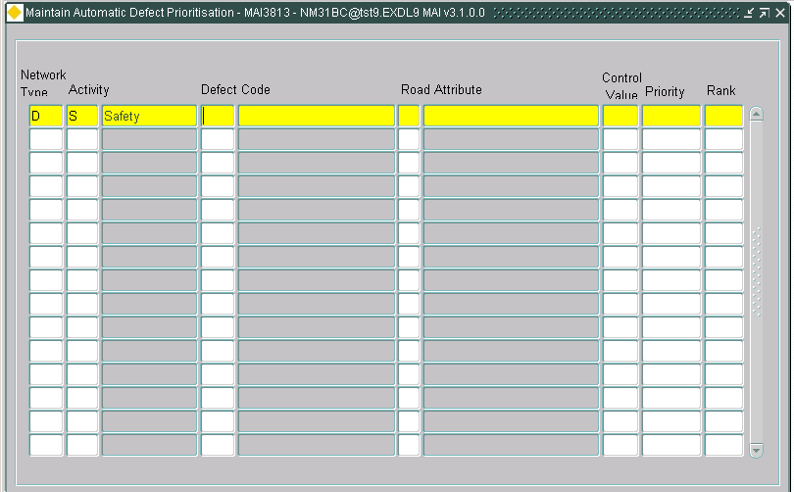
Figure 35

This module allows a Defect Priority to be automatically allocated when a defect is added to the Inspections - MAI3808 form depending on a rule set defined in this form. Automatic priority is “on” when product option ‘DEFAUTOPRI’ is set to ‘A’ or ‘B’.
These rules are a combination of Network Type (i.e. Local, DTP roads), Activity, Defect Code and Road Attribute.
For example, in the case where you have the following rule set:

Network Type | Activity Code | Defect Code | Road Attribute | Control Value | Priority | Rank
L | MC | M01 | RSE_ROAD_ENVIRONMENT | R | 1 | 1
L | MC | M01 | RSE_ROAD_ENVIRONMENT | S | 2.1 | 2
L | MC | M01 | RSE_ROAD_ENVIRONMENT | U | 2.2 | 3

      - You have an Inspection with Activity code of ‘MC’;
      - And a Defect Code of M01;
      - If Road Section (which Defect is on) has RSE_ROAD_ENVIRONMENT = ‘R’ then the rules will determine the Priority, e.g., ‘1’ in this case. Likewise, for a control value of ‘S’ the priority would be 2.1 and for ‘U’, 2.2.
      - The Priority Ranking indicates the order in which the most urgent Priority will be returned to the Inspections form, with ‘1’ being the most urgent. If the Network Type / Activity Code / Defect Code are the same, then the most urgent priority is the one that will be entered on the Inspections form.

Maintain Automatic Defect Priority
Network Type (Required) List
Enter ‘L’ for Local and ‘D’ for DoT, or select from the list.

Activity Code (Required) List
Select from the LOV. The description will appear.

Defect Code (Required) List
Select from the LOV. This description will appear.

Road Attribute (Required) List
Enter the Road Attribute code from the LOV. The description will appear.

Control Value (Required) List
Enter a control value, the contents of this list will depend on the attribute selected in the previous field.

Priority (Required) List
Select a valid priority from the list

Rank (Required)
Enter the desired Rank for this priority.

Loading Inspection Files
The rule set will also be applied to Defects loaded from an Inspections File. If the Product option ‘DEFAUTOPRI’ set to ‘A’, the value of Priority entered in the field and contained in the file will be over-written by the Priority automatically derived from the rules. Therefore, it is extremely important that the ‘DEFAUTOPRI’ value is checked before loading an Inspection file. If the value is anything other than ‘A’, the file will insert the field Priority values.

Treatment Data - MAI1315
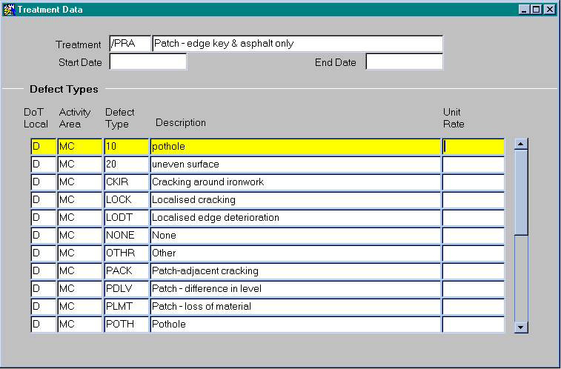
Figure 36

This form defines which defect codes are associated to the selected treatment code. For example a treatment of PVN – Provide New may apply to a number of defects.
The defects will have been previously associated to an inspection activity using Defect Control Data – MAI1300.
Treatment Data
This window is used to create and retrieve treatments so that they can be associated with their corresponding defects.

Treatment (Required)
Enter a treatment type code followed by the description of the treatment in the adjacent field.

Start Date (Optional)
Enter the date when this treatment code became active.

End Date (Optional)
Enter the date when this treatment code becomes inactive.

Defect Types
When an existing treatment is retrieved all associated activities and defects will be retrieved. To associate another activity code / defect combination use [Create Record] then add the details using [List].

DoT / Local (Required)
Enter either 'D' for DoT activities or 'L' for local.

Activity Area (Required) List
Enter the activity area in which the defect occurs. This list of values will also contain the defect type and description.

Defect Type (Display Only)
The defect type will be displayed.

Description (Display Only)
A description of the defect will be displayed.

Unit Rate (Optional)
Enter the monetary amount which will be used to calculate the default cost of this treatment.
Treatment Models - MAI3814
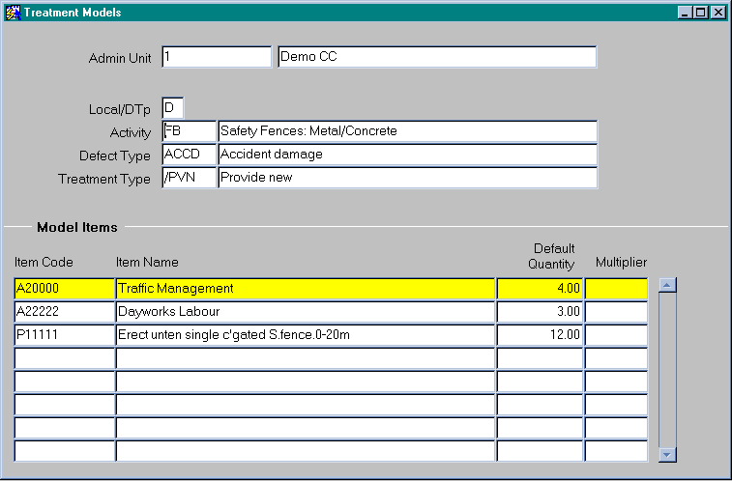
Figure 37

If you wish to use treatment models you must first enable them, this is done using Product Options - HIG9130, set the option to 'Y' for either USETREMODD or USETREMODL for DoT or Local roads respectively.
Treatment models are a method by which a Bill of Quantities can be automatically generated for a particular combination of Inspection Activity, Defect Code and Treatment (Repair) Code. If a suitable treatment model has been defined through this form, whenever a user logs a defect and specifies the appropriate treatment code, the system will generate the relevant Bill of Quantities items. This can be used to obviate the need for the inspector to define the detailed Bill of Quantities whilst on site.
This form allows you to define a treatment model for a specified combination of Activity, Defect and Treatment within an admin unit.
There are two options available when using treatment models.

- Manually define your treatment models using this module.
- The system will automatically generate treatment models when the Product Options - HIG9130 for either GENTREMODD or GENTREMODL for DoT or Local roads respectively is set to ‘Y’. When raising a defect clearance works order using Works Orders - MAI3800, a new treatment model will be created when a defect has a set of BOQ items associated with it and the works order is saved.

When you have created the majority of treatment models using the second option above you can switch off the automatic generation by setting the options to 'N'.
Treatment models are used as a guide, the actual treatments can be modified prior to raising a works order using Inspections – MAI3808 or when raising a works order using Works Orders - MAI3800.

Treatment Models
Here you define the combination of circumstances under which the default items listed below will be carried out.

Admin Unit
Enter the admin unit of the road.

Local/DoT
Indicate whether this treatment model is for use on 'L' local or 'D' DoT owned roads.

Activity
Enter the code of the activity that took place. A description will be displayed in the adjacent field.

Defect Type
Enter the code for the type of defect. A description will be displayed in the adjacent field.

Treatment Type
Enter the code for the treatment type for this defect. A description will be displayed in the adjacent field.

Model Items
Define the default treatment model for the combination defined above.

Item Code (Required) List
Enter the item code of the treatment. These items must have been pre-defined using Standard Items.

Item Name (Display Only)
The item name of the above code will be displayed.

The next two fields are mutually exclusive.
Default Quantity (Optional)
Enter the quantity of the item defined above to be carried out for this treatment.
For example, traffic management is not directly linked to a defect but you may always have a minimum of 2 hours as the default.

Multiplier (Optional)
Enter a multiplier for this item. This multiplier is applied to the first attribute of the defect as set up in Defect Control Data. This could allow you to set a multiplier of 0.001 if you wish to convert a value from metres to kilometres.
Default Treatments - MAI3150
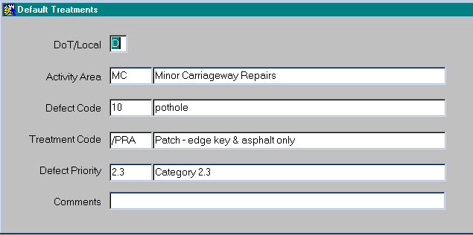
Figure 38

This form is used for maintaining default treatments for defects. Each defect can have a default treatment depending on the activity area and priority of the defect.
If the on-site inspector has recorded a treatment for a defect, this treatment will be used in preference to the default treatment. If, however, the inspector does not enter a value, the inspection load program will automatically assign the default treatment specified when the inspection is loaded onto the system.
Default Treatments
A treatment is assigned to the combination of activity area, defect code and priority here.

DoT / Local (Required)
Indicate whether this default treatment is for use on 'D' DoT or 'L' local owned roads.

Activity Area (Required) List
Enter the activity area for the treatment.
The activity areas will have been set up using Activities.

Defect Code (Required) List
A valid defect code must be entered, a description will be displayed in the adjacent field.
The defects will have been set up using Defect Control Data.

Treatment Code (Required) List
Enter the default treatment code that is to be associated with the defect code selected in the previous field. A description will appear in the adjacent field.
Valid treatments will have been set up using Treatment Data.

Defect Priority (Required)
Enter the defect priority.
Valid priorities will have been set up using Defect Priorities.

Comments (Optional) Edit
Enter any comments required.
Enquiry/Treatment Types – MAI1320
Figure 39
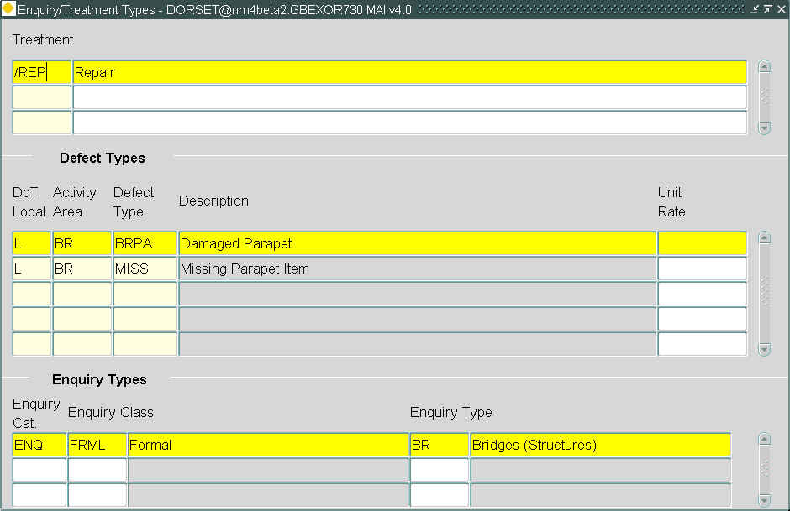

Linking defects (and hence inspections) to public enquiries is a two stage process using Enquiry/Defect Types and Enquiry/Defect Priorities.

This form is used to link enquiries to defects and will automatically generate a defect whilst in Public Enquiries – DOC0150 when the correct criteria are met.
Treatment
Treatment (Required) List
Enter a valid Maintenance Manager treatment code, a description will be displayed in the adjacent field.

Defect Types
All the defect information displayed here is existing data relating to the selected repair. Select the defect you wish to associate to an enquiry type then move to the Enquiry Types block.

The defect and treatment combination will form the list of values that is displayed to the user in the Enquiry Manager form.
Enquiry Types
An existing enquiry category/class/type combination is specified here to link with the previously selected defect type.

Enquiry Cat (Required) List
Enter a valid Enquiry Category.

Enquiry Class (Required) List
Enter a valid Enquiry Category, a description will be displayed in the adjacent field.

Enquiry Type (Required) List
Enter a valid Enquiry Type, a description will be displayed in the adjacent field.

Enquiry/Treatment Priorities – MAI1325
Figure 40
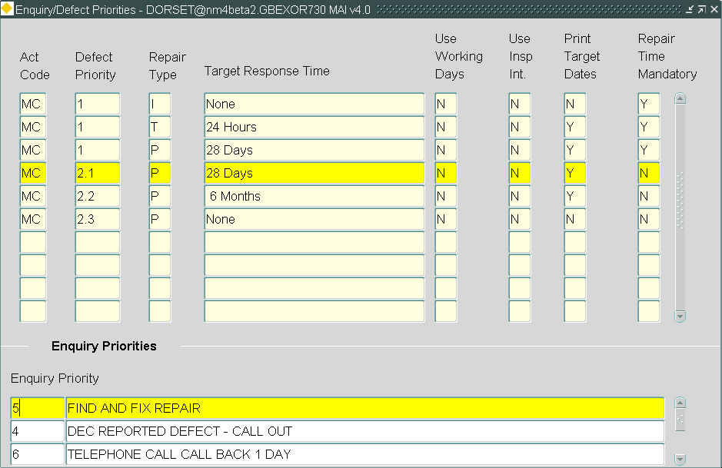

Both defects in Maintenance Manager and enquiries Enquiry Manager may have different priorities for various operational reasons.
This module is used to link these priorities when creating a defect from an enquiry.
Activity / Priority
Query back the activity whose defects will be linked to an appropriate enquiry. Then select the priority required.

Enquiry Priorities
An existing enquiry priority is specified here to link with the previously selected defect priority.

Enquiry Priority (Required) List
Enter a valid Enquiry Priority.

CHAPTER
6
Contracts and Contractors
The terminology used by Maintenance Manager considers that “contractors” under the terms of a “contract” accomplish all work. A further assumption is that most work is pre-priced through bids on an indefinite delivery or task order contract. If in-house work forces and resources are being used to accomplish the work, the in-house capabilities and costs can be defined in the same way as a contractor’s, and the name of the contractor could be something like “Area Office 22”, or “Field Team 4” or some similar designator. In this way it is possible to compare the cost of doing work in-house versus using a contractor and it also accommodates cost comparisons between different in-house maintenance teams and different contractors.
To simplify the process of pricing a Work Order, MM uses Standard Items (a Schedule of Rates) against which the work is to be done. These Standard Items are held centrally as a catalogue of work items, each having a standard rate for estimating purposes. Actual quoted can be applied to some or all of the schedule items by creating a contract. Therefore, a “contract” is simply a record that certain Standard Items are valid for a certain contractor or in-house work crew between two dates, and the cost quoted by that Contractor for each ‘Item’ of work. When a Work Order is created, it can be described as a certain quantity of pre-priced Schedule of Rates items. If the Work Order requires work that is not on the Schedule of Rates, a “rogue” item can be defined and priced when the Work Order is created.
Before creating a contract, a Schedule of Rates and least one contractor should be created.
If any Contract Items can attract a Percentage increase or decrease i.e. have the 'Allow percentage Items?' field set to 'Y' in Standard Items - MAI3888, then the Percentage Items associated with these Job Items must also be added as Contract Items to the Contract.
Contract details can only be modified if the status of the contract is set to ‘Inactive’ in the Contracts form MAI3880.
The forms used to manage Contractors and Contract details are:

- Standard Items - MAI3888
- Standard Item Sections and Sub-Sections - MAI3886
- Contractors - MAI3881
- Contracts - MAI3880
- Copy a Contract - MAI3882
- Bulk Update of Contract Items - MAI3884
- Discount Groups - MAI3624
Figure 41
Contracts and Contractors
Menu Options
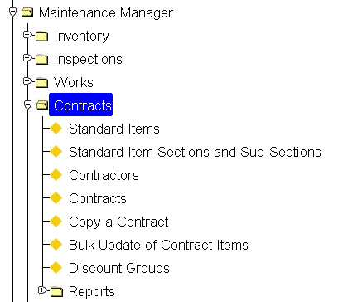
Standard Items - MAI3888
Figure 42
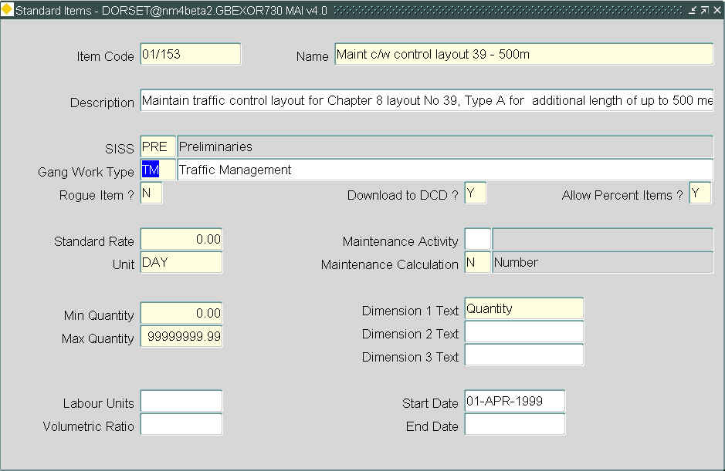

All work scheduled through highways by exor must be selected from a list of predefined standard job items. These items are defined through this form.
A bulk loading utility is available to enable standard items to be loaded from an external system once formatted correctly. Contact the support desk for further information.

A Job Item may be flagged as allowing a percentage item to be calculated against it by entering a 'Y' in the 'Allow Percent Items?' field. This will allow a Bill of Quantity item known as a Percentage Item to be associated with the selected Job Item when creating Works Orders. A Percentage Item attracts a percentage uplift or reduction to the Bill of Quantity Item to which it is associated. For example, work carried out on Bank Holidays may attract a surcharge. Adding a percentage Item to the BOQ would allow this surcharge to be applied.
Percentage Items are those Standard Job Items which have the Unit of Measurement as defined for Product Option PERC_ITEM e.g. PERCENTAGE. For information on adding Percentage Items to a Works Order see the Works Ordering Manual.

If product Option DUMCONCODE is set to a valid Contract, thus using the Dummy Contract functionality for Works Ordering, the 'Dummy' contract will be automatically maintained in line with any standard item inserts, deletes or rate changes.

Standard Items
Item Code (Required)
Enter the code to represent this standard job item.

Name (Required) Edit
Enter a brief textual description of the standard job item. This description should be detailed enough to allow easy identification of the nature of the work to which it refers. This field is may contain up to 254 characters.
Note that Double Clicking in this field will open the edit window allowing long Standard Item Names to be displayed in full.

Description (Optional) Edit
If required, enter any additional descriptive text. This field is may contain up to 2000 characters.
Note that Double Clicking in this field will open the edit window allowing long Standard Item Descriptions to be displayed in full.

SISS (Required) List
Select a valid Standard Item Sub Section code. These codes are defined using Standard Item Sections and Sub Sections – MAI3866.

Gang Work Type (Optional) List
This field will be displayed when the product option GANGENABLE is set to ‘Y’.
The gang work type is linked to the Standard Items to act as a means of selecting defects when raising a works order.
The gang work type list of values is maintained in Domains – HIG9120 under the GANG_WORK_TYPE domain.

Rogue Item? (Required, Default) List
Enter ‘Y’ if this standard item is a ‘Rogue Item’, default is 'N'. A rogue item does not refer to a real item of work with its associated cost but rather it is used as a wildcard to allow non-standard job items to be defined on a works order.
When a rogue item is entered against a defect, the user enters the work description, rates and quantities.

Download to DCD (Required, Default)
If this standard item is to be flagged for download to a DCD enter 'Y'. default is 'N'. Only those items that have been downloaded can be used to defining defect repairs via the DCD.
If 'Y' is entered, the standard item will be included next time Download Standard Item Data for DCD Inspections or Download Assets by Inspection is run.

Allow Percent Items? (Required, Default)
If a Percentage Item can be associated with this Job Item when creating Bill of Quantity Lines on Works Orders, enter 'Y'. The default value is 'N'.
Note that if this item is a Percentage Item the value entered should be 'N'.

Standard Rate (Required)
Enter the standard rate for this item of work. This standard rate will be superseded by the rates entered when this standard item is entered onto a contract using Contracts - MAI3880. If the Dummy contract as defined in Product Option DUMCONCODE is used during the initial preparation of a Works Order these Standard Rates will be used to calculate an estimated cost.
Note that if the Item being entered is a Percentage Item, the Standard Rate equates to the % uplift or decrease to be associated with another Item e.g. 10 or -10.

Maintenance Activity (Optional) List
If required, enter the cyclic maintenance activity that relates to this item.
These activities will have been set up using Activities.

Unit (Required) List
Select the unit of measurement for the rate above. If this Item is a Percentage Item, the value entered should be that defined for Product Option PERC_ITEM.
These values will have been previously set up using Domains - HIG9120 and updating the ATV_UNIT option.

Maintenance Calculation (Optional) List
If this standard item is to be included in a cyclic maintenance schedule enter the calculation type here. If you wish to use cyclic maintenance to calculate areas use 'T' - Trapezium area rule, for lengths use 'L' - Length and for numbers use 'N' - Number.
If areas are to be calculated when carrying out Cyclic Maintenance, this value must be set to 'T'.
These values will have been previously set up using Domains - HIG9120 and updating the ATV_CALC_TYPE option.

Min Quantity (Required)
Enter the minimum quantity of work which can be carried out under this job item.

Max Quantity (Required)
Enter the maximum quantity of work which can be carried out under this job item.
Note that if the minimum or maximum quantities are either under or over specified when associating to defects an error message will result, pressing the [Expand] key will display the minimum and maximum allowable values for the selected item.

Dimension 1 Text
Dimension 2 Text
Dimension 3 Text (Required, Optional)
As each job item used to repair a defect, the inspector can add extra information concerning the dimensions of the work to be carried out. These dimensions can, of course, vary from one item to another. The ‘dimension’ fields allow up to three additional pieces of text to describe the dimensions of the repair.

Labour Units (Optional)
If a labour unit multiplier is to be used enter a value here.

Vol Ratio (Optional)
Enter a volumetric ratio. This is used to turn an item quantity into a volumetric quantity, e.g., from metric into cubic meters.

Start Date (Optional)
Enter the date from which this job item is effective. If a date is supplied, the item cannot be used before that date.

End Date (Optional)
Enter the date from which this job becomes ineffective. If an end date is supplied, the item cannot be used after that date.
Standard Item Sections and Sub-Sections - MAI3886
Figure 43
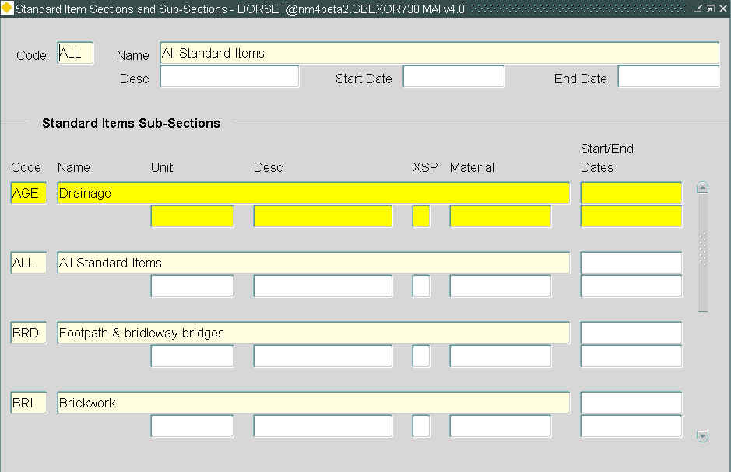

This form is used to define the item sections and sub-sections into which previously defined standard job items may to be grouped.
The standard job items are defined using Standard Items – MAI3888.
Standard Item Section
Standard item sub sections are split into groups using this option.

Code (Required)
Enter the code to represent the group for the standard item section.

Name (Required)
Enter a brief textual description of the standard item section. This description should be detailed enough to allow easy identification of the nature of the section to which it refers.

Desc (Optional)
If required, enter any additional descriptive text.

Start Date (Optional)
Enter the date from which this item section is effective. If a date is supplied, the item cannot be used before that date.

End Date (Optional)
Enter the date from which this section becomes ineffective. If an end date is supplied, the item section cannot be used after that date.

Standard Item Sub-Sections
Once the standard item section has been defined enter the Standard Item Sub-Sections (SISS). These are used as a method of grouping standard job items together.

Code (Required)
Enter the code to represent the standard item sub-section.

Name (Required)
Enter a brief textual description of the standard item sub-section. This description should be detailed enough to allow easy identification of the nature of the sub-section to which it refers.

Desc (Optional)
If required, enter any additional descriptive text.

XSP (Optional) List
If required, select the XSP to which this item sub-section refers.
These values can be added to using Domains - HIG9120 and updating the XSP_TYPE option.

Material (Optional) List
If required, select the material to be used in carriageway/footway resurfacing work. When work of this type is carried out within the Structural Projects Manager module, the road construction data is updated with this material information.
The materials will have been set up against the materials attribute in the Road Construction (RC) inventory item using Inventory Control Data - MAI1400.

Start/End Dates (Optional)
Enter the dates which define the effectiveness of the item sub-section codes. If start and end dates are supplied, the item sub-section cannot be used before and after those dates.

Contractors - MAI3881
Figure 44
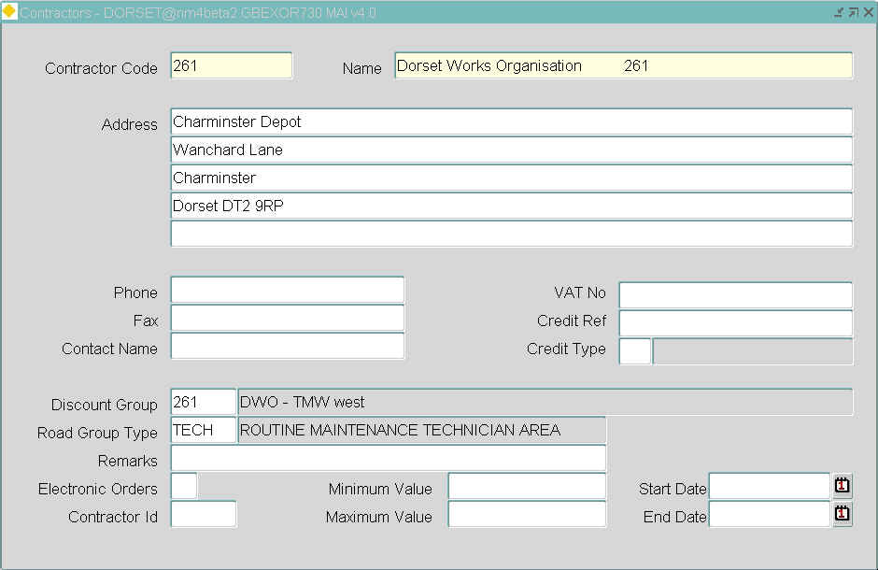

This module is used to record details of each contractor against whom contracts will be created. It is not possible to raise a contract until the associated contractor has been created.
The Minimum and Maximum Values of Works Orders allocated to a Contractor can be set using the 'Minimum Value' and 'Maximum Value' fields respectively. If the total value of the Works Order is outside these limits a warning will be displayed, as in Figure 44 , when the Contractor is selected via the [Contract Totals] window on the Works Order (Defects) form.
Contractors
Contractor Code (Required)
Enter a code to uniquely identify this contractor.

Name (Required)
Enter the full name of the contractor.

Address (Optional)
Enter the full contact address of the contractor

Phone (Optional)
If required, enter a contact telephone number for the contractor.

VAT No (Optional)
If known, enter the contractor’s VAT number.

Fax (Optional)
If required, enter a fax number for the contractor.

Credit Ref (Optional)
If required, enter the credit reference number.

Contact Name (Optional)
If required, enter a contact name for the contractor.

Credit Type (Optional) List
If required, select the type of credit the contractor allows.
These values can be added to using Domains - HIG9120 and updating the CREDIT_TYPE option.

Discount Group (Optional) List
If you wish to apply a discount or surcharge to any work carried out by this contractor enter the discount group here.
Discount groups are used to associate a discount or surcharge to the cost of a works order based on the cost of the order for a selected contractor
Discount groups are maintained using Discount Groups – MAI3624.

Road Group Type (Optional) List
If the contractor is to be restricted to working on a selected road group enter the road group type here.

Remarks (Optional)
If required, enter any additional comments relating to this contractor. These remarks are NOT printed on any works order reports.

Electronic Orders (Optional, Default)
If Electronic Orders are to be raised for this Contractor enter 'Y'. The default setting is 'N'. (For more information on Electronic Ordering see the Interfaces Manual)

Contractor Id (Optional)
Enter a 3 Character code for the contractor identifier. This identifier will be used in the naming of files and will be mandatory if the Electronic Order flag is set to 'Y'.

Start Date (Optional)
Enter the date the contractor becomes effective from.

End Date (Optional)
Enter the date from which the contractor ceased to be effective.
Contracts - MAI3880
Figure 45
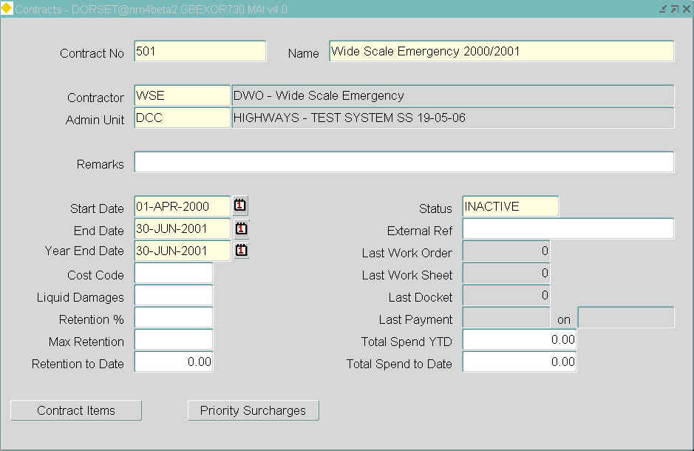

This module stores basic contract details, the associated contract items and rates with any priority surcharges for high priority work.
Since rates can vary by road group, contractors can charge different rates for different parts of the road network, depending on their remoteness, levels of traffic, typical grades (mountainous areas may be more than flat areas) and sof forth. Note that road groups can be associated with schedule items in the contract items window
If any Contract Items can attract a Percentage increase or decrease i.e. have the 'Allow percentage Items?' field set to 'Y' in Standard Items - MAI3888, then the Percentage Items associated with these Job Items must also be added as Contract Items to the Contract.
If the DUMCONCODE Product Option (HIG9130) is enabled, a Contract named “Dummy” can be created that contains every standard item with estimated costs. The ‘Contract No’ assigned to this dummy contract should entered as the ‘Current Value’ in the DUMCONCODE Product Option (HIG9130). This Dummy contract can now be used to set up and estimate the cost of a Work Order before an actual contractor is assigned. The Dummy contract can be maintained and copied at year’s end in the same way as a real contract. If you are not using dummy contracts, set this option to DISABLED
In Standard Items - MAI3888 the dummy contract is automatically maintained in line with any standard item inserts, deletes or rate changes.
In Work Orders - MAI3800 (See the Users’ Manual) the dummy contract may be selected by any user, regardless of their assigned Admin unit.
The DUMCONCODE Product Option can be amended on a live system.

Contracts
Contract details can only be modified if the status of the contract is set to Inactive.

Contract No (Required)
Enter a reference to uniquely identify this contract. This reference can contain alphanumeric characters.

Name (Required)
Enter a descriptive name for this contract.

Contractor (Required) List
Select the contractor with whom this contract has been made. Contractors are created through Contractors.

Admin Unit (Required) List
Select the admin unit to which this contract will apply.

Remarks (Optional)
If required, enter any additional comments relating to this contract.

Start Date (Required)
Enter the date on which the contract comes into force.

End Date (Required)
Enter the end date of the contract. This contract will be unavailable for use after this date.

Year End Date (Required)
Enter the year end date of the contract. This allows the user to continue to complete works orders against this contract after the end date of the contract

Cost Code (Optional)
If required, enter a cost code.

Liquidated Damages (Optional)
If required, enter the daily rate of liquidated damages to be inflicted if the target completion date is overrun. If no liquidated damages are to be applied, leave this field blank.
These liquidated damages can be reported on using List of Contractor Liabilities
It is possible for the system to automatically calculate payment retention's for works order. If a contract includes retention's, the next two fields determine how those retention's are calculated.

Retention % (Optional)
Enter the percentage retention to be automatically applied to each completed works order under this contract. If you do not wish to have a retention against this contract, leave this field blank.

Max Retention (Optional)
Enter the maximum value of any retention for this contract.

Retention to Date (Optional)
This will display the amount of retention to date based on the above two fields.

Status (Required) List
This field contains the contract status. This can be either ‘Active’ or ‘Inactive’. If the status is ‘Active’, the contract can be used to raise works orders against.
To amend the details of the contract itself, including the contract items or their rates, the status must be set to ‘Inactive’. Initially, therefore, leave this field as ‘Inactive’.

External Ref (Optional)
If required, enter the reference by which this contract is known to the contractor.
If a contract has been in existence for some time, although not on the highways by exor system, it is possible to bring highways up to date as you enter the contract details. The next seven fields can be entered at contract creation time to bring the system up to date with reality. Once the contract is Active and running, these fields will be kept up to date automatically throughout the life of the contract.

Last Work Order (Optional)
If required, enter the number of the last works order issued against this contract.

Last Work Sheet (Optional)
If required, enter the number of the last work sheet for the works order above.

Last Docket (Optional)
If required, enter the number of the last docket to be issued against this contract.

Last Payment Value (Optional)
If required, enter the value of the last payment made against this contract.

on (Optional)
If required, enter the date that the last payment was made.

Total Spend YTD (Optional)
If required, enter the total spent for the current year to date against this contract. Note that figure represents the value of work done before any retentions are subcontracted.

Total Spend To Date (Optional)
If required, enter the total spent against this contract.

Contract Items Button
Figure 46
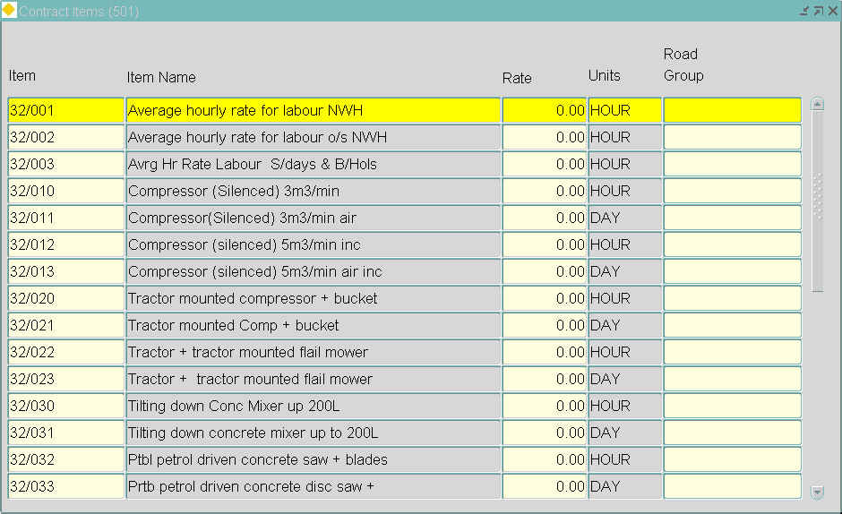

This window is displayed by selecting the [Contract Items] button and contains a list of the standard job items, which relate to the current contract along with the contract rate for each item. On creation of the contract you will need to define these items and their rates. Subsequently, you can use this window to view the items.

Item Code (Required) List
Select a standard job item from the List of Values.
These job items are set up and maintained using Standard Items - MAI3888 (Defect and Inspection Manual).

Item Name (Display Only)
Displays the full description for the standard job item.

Rate (Required)
Enter the rate for this item.
Note that if the Item being entered is a Percentage Item, the Standard Rate equates to the % uplift or decrease to be associated with another Item e.g. 10 or -10.

Units (Display Only)
Displays the unit in which this item is measured. This is used in conjunction with the Rate field above to record the ‘cost per unit’ under the terms of this contract.

Road Group (Optional) List
If required, enter a road group to represent the area for which this rate is valid. Using this field allows you to record several different rates for the same item in different road groups and hence different geographical areas.

Priority Surcharges Button
Figure 47

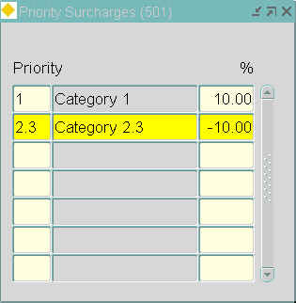

This window is displayed by selecting the [Priority Surcharges] button and allows the user to enter a percentage surcharge that will be applied to the Rate for different priorities of defects.

Priority (Optional) List
Enter a defect priority, a description will be displayed in the adjacent field.

% (Required)
Enter a percentage value that represents the surcharge. A negative value will apply a discount.
Copy a Contract - MAI3882
Figure 48
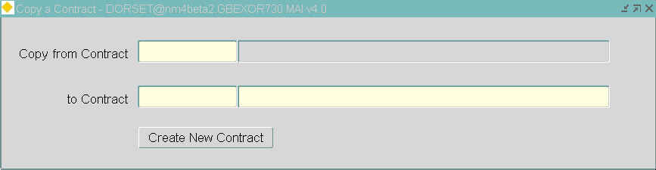

This option allows you to copy an existing contract, creating a new contract in the process. The original contract is unchanged by this process.
A useful application for this facility would be as a way of creating a new annual contract for a new year whilst leaving the previous year’s contract untouched.
If updates are to be made to a contract it is wise to take a copy of the contract prior to any updated being made so a history of the original rates is maintained.
Copy a Contract
Copy From Contract (Required) List
Select the contract to be copied from. This contract is not changed in any way by this process.

Copy To Contract (Required)
Enter a new contract number. This contract will be created as an identical copy of the contract specified in the Copy From: Contract parameter.
Having completed the two fields, select the [Create New Contract] button to create the new contract.
At this point the contracts details that have changed can be amended manually using Contracts – MAI3880. Alternatively, Bulk Update Of Contract Items – MAI3884 could be used if all of the contract rates have increased by the same percentage. If most of the values have changed by the same percentage, but some are different, use Bulk Update and then change the different items manually.

Bulk Update of Contract Items - MAI3884
Figure 49
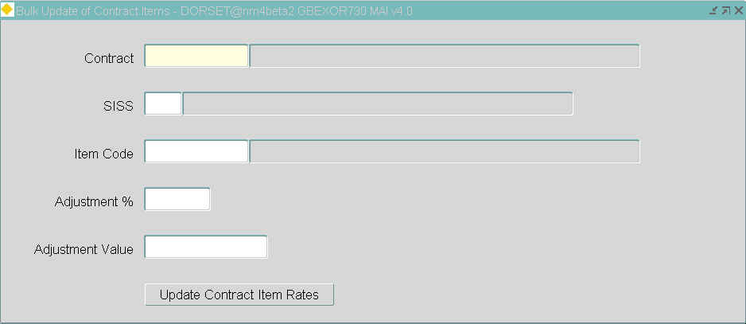

This option will apply an increase to all contract rates meeting the criteria specified in the parameters. This enables the update of certain areas on the contract whilst leaving other areas unaffected by any changes.
For example, an update may only be applied to premium or night rates.
To maintain historical data, it is suggested that, prior to running this screen, a copy of the contract is taken using Copy a Contract – MAI3882 and this new contract is updated, leaving the original contract at the old rates.
Note that before running the bulk update, you must ensure that the contract status is ‘Inactive’. This can be changed using Maintain Contracts – MAI3880
Bulk Update of Contract Items
Contract (Required) List
Select the contract to be updated. A description will be displayed in the adjacent field.

SISS (Optional) List
If required, select a SISS code to restrict the rates which will be updated. Only the rates for those items which match the specified SISS code will be updated.

Item Code (Optional) List
If required, select a job item code to restrict the rates to be updated. Only the rates for those items which match the specified item code will be updated. Both '%' and '_' wildcards may be used.
For example,
A% will update all the 'A' series of items by the amount specified
B100% will update only the 'B100' series of items
_100% will update all 'A100', 'B100', 'C100'….'n100' series of items
The following two fields determine the nature of the increase (or decrease) in rates. You must complete ONE of these fields, to indicate either a percentage uplift or a fixed value of uplift.

Adjustment % (Optional)
If required, enter the percentage uplift you want to apply to the items matching the selection criteria above. This percentage can be preceded by a minus sign (-) to indicate a rate reduction by the specified percentage.
OR

Adjustment Value (Optional)
If required, enter an absolute value by which all items matching the selection criteria above will be uplifted. This value can be preceded by a minus sign (-) to indicate a rate reduction by the specified amount.
Select the [Update Contract Item Rates] button to uplift the contract
Reactivating the Contract
Before using the contract again, you must set the contract status back to ‘Active’.
Discount Groups - MAI3624
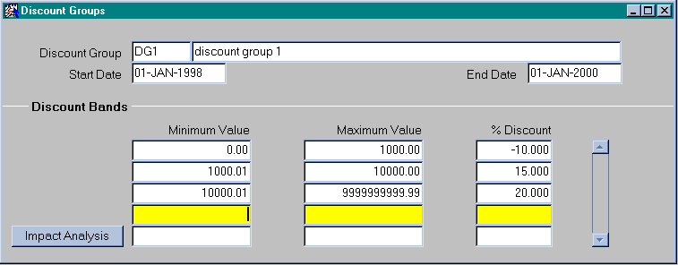
Figure 50

Discount groups are used to associate a percentage discount or surcharge to the cost of a works order based on the cost of the order for a selected contractor.
Discount groups are associated to a contractor using Contractors – MAI3881, contractors may be associated to one or more contracts using Contracts – MAI3880 , any work raised using these contracts will have a discount group applied to the final estimated value.
The result of any discount will be shown in the balancing sum fields in the works ordering forms.
This form is used to create and maintain discount groups and their associated discount bands.
An individual discount group could be used by more than one contractor. It is therefore important, when making changes to the discount bands, that the Impact Analysis window is checked to see the full impact of your proposed changes.
If necessary discount groups can be set up on a monthly basis and applied to contractors to take into account monthly fluctuations in the cost of works etc.
A surcharge can be applied to an order of a given value by entering a negative value.
Note Discount Groups must not be used when the Contractor Interface –CIM is being used.

Discount Group
When you enter this window, the cursor sits in the Discount Group field waiting for you to enter a new discount group and associated descriptions.
To view existing discount groups, press [Enter Query] followed by your selection criteria, then press [Execute Query] to retrieve the required group.

Discount Group (Required)
Enter the code for this discount group.

Description (Optional)
Enter the description for this discount group.

Start Date (Optional)
Enter the date which this discount group became valid from.

End Date (Optional)
Enter the date which this dicount group is valid to.

Discount Bands
The discount bands are entered here, the minimum and maximum values must cover the full range of values from 0 to 9999999999.99. When entering these ranges there must be no gaps or overlaps of the values.
A negative value in the discount field will lead to a surcharge.

Minimum Value (Required)
Enter the minimum value for the discount band.

Maximum Value (Required)
Enter the maximum value for the discount band.

% Discount (Required)
Enter the percentage discount that is to apply to the range of values entered. A negative value will lead to a surcharge instead of a discount.

Impact Analysis Button
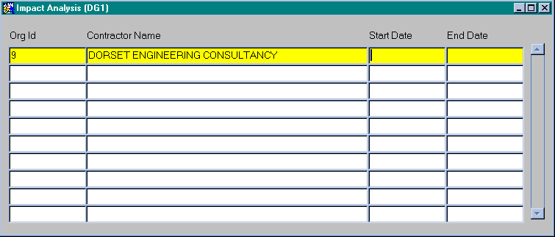
Figure 51

When you select the Impact Analysis button the system will automatically query back the relevant contractors.
If you intend to make any changes to the discount bands, this window should be checked to see what impact the changes that are to be made will have on the contractors that use this discount group, e.g. one contractor using this discount group may change their discount structure, while another, also using this group, does not.

